**CSE 515 Multimedia and Web Databases Phase 1: Image Feature extraction and Similarity Search**

(Group – 10)

Group Members:

1. Devanshu Gupta
2. Sonal Sujith Prabhu
3. Surya Makkena (Submitted by)
4. Vaibhav Somani
5. Vikas Kamineni
6. Vishal Reddy Eda

**Abstract:**

In this project we implement a program to extract feature descriptors based on different features of an image. Some of the features of images which can be extracted are Color, Shape, Texture, Segments, Shapes etc. For this project, we are confining it to only 5 feature vectors which are Color Moments based on color of an image, Histogram of Oriented Gradients which represents the texture of the image, and 3 types of feature vectors from the pre-trained neural network ResNet50 which analyses the patterns in the image. These feature descriptors are highly useful to distinguish one image from another. We use vector model for the data representation because for this project we are only considering the frequency of features in the images. We compute different features for each image and store them in a JSON based on image Id which can be used for easy retrieval of data. For the final step, we implement a program to find k similar images for the input image in each vector space using different similarity measures. The final k images we are getting might not be the exact match as we are not eliminating any background noises that might interrupt the pattern recognition. This feature extraction can be used in combination with feature selection and dimensionality reduction to retrieve meaningful information from the image.

**Keywords:** Features, Vectors, Classification, Similarity function, Similarity score, Color Moments, Histogram of Oriented Gradients

**Introduction:**

Feature extraction is the process of getting important information from the given set of images where we convert large amount of raw data (which is hard to understand) into representation of meaningful information. Feature extraction is useful for object recognition, object classification etc. by extracting key visual features which describes the image. There are multiple features that can be extracted from the images such as color, texture, shape, edges, patterns etc. The feature descriptors that we used in this project are color Moments, Histogram of Oriented Gradients, Average pool layer feature descriptor, layer3 and fully connected layer feature descriptors.

Color moments are feature descriptors which measure similarity between color of the images and is used to differentiate images based on color. The moments we extracted are mean, standard deviation and skewness for each color channel in the RGB color representation.

Histogram of Oriented Gradients is a feature descriptor used to distinguish images by extracting information related to distribution of gradient orientation in an image. Here we calculate the frequency of orientation of each pixel by convoluting with a filter mask in both horizontal and vertical directions. While computing the HOG features, we convert the image from RGB to Gray scale as we only focus on the orientation of the objects, how the image texture is changing with respect to borders in the image and we do not consider any color related information.

ResNet50 is a pre-trained neural network architecture model. This neural network is pre-trained with default weight to classify 1000+ images into separate categories as Laptop, books, faces etc. It contains various layer where the model extracts features based on the pattern recognition and it is used to distinguish or classify images according. In this project, we are extracting features from 3 layers of ResNet50 by passing our image to it. The avg_pool layer which extracts the basic features of the image, the layer 3 which extracts high-level features, and fully connected layer i.e. the final layer which abstractly describes the images.

In this project, our goal is to compute the above-mentioned feature descriptors and store them for easy access. Using these feature descriptors we have to retrieve k similar images to a given image using similarity measures appropriate to the data distribution. First, we have implemented functions/methods to compute the feature descriptors and stored them in a JSON file with image_id as the key. Using this data in JSON, we can print feature descriptors of any images based on the user request in a human readable way. Finally, using appropriate distance measures, we calculate the similarity score between given Image and other images with respective to each feature descriptors and show the output by printing the top k similar images in each vector space.

The dataset that I considered is Caltech101 as per the given problem statement. To implement this program, I only considered the data which has all 3 color channels. If there is an image without all 3 color channels then I am skipping those images.

**Proposed Solution:**

From the Caltech101 dataset, I have converted every image into a numpy array which includes 3 color channels representing Red, Green, Blue. I have partitioned each image with a 10, 10 grid after resizing the initial image to (300,100) as per the problem statement. After partitioning, we get 100 Images of shape (30,10) which when converted to numpy will change to (10,30) shape. For each color channel of every cell, I calculated color Moments Mean, Standard Deviation and skewness using the formulae mentioned in the slides. The color moments of each cell are stored in a tuple which are reshaped to (10, 10, 3, 3) where the 10, 10 represents the 100 cells we got after portioning and in the remaining (3,3) matrix, the row represent the color moments of each color channel and the columns represent the color moments mean, standard deviation and skewness.

For Histogram of Oriented Gradients, I converted the image to a Gray scale image as we are not focussing on the color distribution for this computation and we are only concentrating on the texture distribution. We partition the images using 10, 10 as mentioned above and for each cell, we calculate gradients across horizontal and vertical axis by convolving the [-1, 0 ,1] and its transpose in the horizontal and vertical directions. We take padded 0 values when calculating border gradient values. After getting gradient values, we use them to calculate the magnitude and orientation of the cell. In this project, we are considering 9 bins where each bin is divided into 40 degrees and the orientation, we calculated in the previous step is used to assign a bin for the orientation. We convert the orientation to be in range of 0 – 360 degrees and based on the orientation, we assign the magnitude of that cell to that particular bin. Based on this calculation, we map a histogram which gives us feature descriptors.

To get features from ResNet50 pre-trained model, We import the ResNet50 pre-trained model where it has default weights assigned and trained with some image_data. We define 3 hooks, one for each layer we need feature descriptors from. For this project, the feature descriptors are retrieved from the Average Pool Layer, Layer 3 and Fully Connected Layer. The defined hooks are registered as the forward hooks because we are trying to access the feature descriptors of the layer which is the output of the layer on activation. After registering the hooks, we pass every image to the model and retrieve the feature descriptors. From the avg_pool_layer, we get 2048 dimensional array but as per the problem statement, we have to diminish the dimensions by averaging the consecutive elements. So, we reshape the image to (1024, 2) shape and we use mean along axis = 0 to reduce its dimensions. Dimensionality reduction helps to reduce complexity in the data and achieve better results. From the layer-3 hook, we get (1024, 14, 14) dimensional matrix. We apply dimensionality reduction on this result by averaging up 14, 14 slice resulting in 1024 dimensional vector. From the fully connected layer hook, we get 1000 dimensional feature descriptor array.

After computation of all Feature vectors, the data is saved into a JSON file.

To retrieve the Feature Descriptors of a given image, the program loads the JSON file and retrieves the data present for the image_id which is saved in the previous step.

To get k similar images: To get k similar images, we can use different similarity measures for each feature descriptors.

For color moments, I used Manhattan distance which is also known as Minkowski distance of degree 1. I used this because the color moments are numerical data and we can calculate how dissimilar one color is from another where the magnitude will take more precedence over other features.

For HOG, I used Cosine similarity function as here we are more concerned about the orientation of the data than the magnitude and cosine similarity works better with this kind of data. I got better results using pearson correlation but pearson similarity measure is better suited when the data is linearly dependent and it takes both magnitude and orientation into consideration.

For ResNet Layers Avg_pool and Layer 3, I used Euclidian distance also known as Minkowski distance of degree 2. I used this because the layers uses patterns to distinguish images and distance measure can work better to get the similarity in multi dimensional features where we can know how dissimilar one pattern is from another.

For Fully Connected Resnet Layer, I used cosine similarity function as the features will be abstractly described in the fully connected layer and the magnitude might not have much impact.

**Installation and Execution Instructions:**

The basic requirements for the System is 8 GB ram, upto 1 TB storage and i5 processor. If these basic requirements are not met, the program might take longer time to run and the pc performance might get affected. Regarding the software installation for this program, the program is written python environment. So, python 3 or higher version is recommended. The program uses various libraries and packages which has to be installed through PIP. You can use the command pip install <library_name> to install the packages.

libraries that needs to be installed using PIP are are torchvision, numpy, scipy, scikit-learn, Pillow, matplotlib

Execution steps:

We have to either clone the Repository from the github or unzip the zip file to get the program files in your local setup. Once everything is setup, we can use command prompt to go to the file location using cd command and then run the python file using the command python <file_name>.

The programs starts executing and shows a Menu of options to select from. The Menu includes 1. To get Feature Descriptors for a given Image Id 2. To Compute and Store feature descriptors for all images and 3. To retrieve k similar images for a given image.  
  
If you are running the program for the first time it’s better to select 2 because it will compute and store all the feature descriptors in a JSON file. Without this step, there won’t be any data to retrieve the k similar images or to retrieve the feature descriptors of the given image_id.  
  
So, please select 2 for the first time:

Once 2 is selected, the program will try to download the dataset images in the current working directory. If the dataset is already available, then it will just skip the download. Once the dataset is downloaded, the program continues to execute and compute all the Feature Descriptors as per the logic mentioned in the proposed solution. You will see the image_id for which computation is taking place in the output. After all the feature_descriptors are retrieved it will save them in a JSON file with the format

“image_id” : {

“colourMoments” : array of shape (10,10,3,3) representing the color moments.  
 “HOG” : array of shape (900,) representing the Histogram of Oriented Gradients.

“avg_pool” : array of shape (1024,) representing the feature descriptors extracted from the avg_pool layer of ResNet50.

“layer3” : array of shape (1024,) representing the feature descriptors extracted from the layer3 layer of ResNet50.

“fc” : array of shape (1000,) representing the feature descriptors extracted from the fc layer of ResNet50. }

Once data is successfully saved in the JSON file, you will see the message data saved successfully. This JSON file is automatically created if it doesn’t exist in the cwd. This entire operation takes 3-4 hours.

Since Operation 2 is completed, it will ask for user input on whether you want to go to menu or exit. To go to the Menu press 1. To exit give 2.

In the Menu, you will get same options as 1. To get Feature Descriptors for a given Image Id 2. To Compute and Store feature descriptors for all images and 3. To retrieve k similar images for a given image.

Now, You can select 1 or 3 based on the requirement.

If 1 is selected:

The program will ask for Image Id for which you need color Moments. Please enter the imageId. If the image doesn’t exists or is a gray scale image then you will receive a message saying so, otherwise it will retrieve the JSON file and search for data related to the image_id and prints it.   
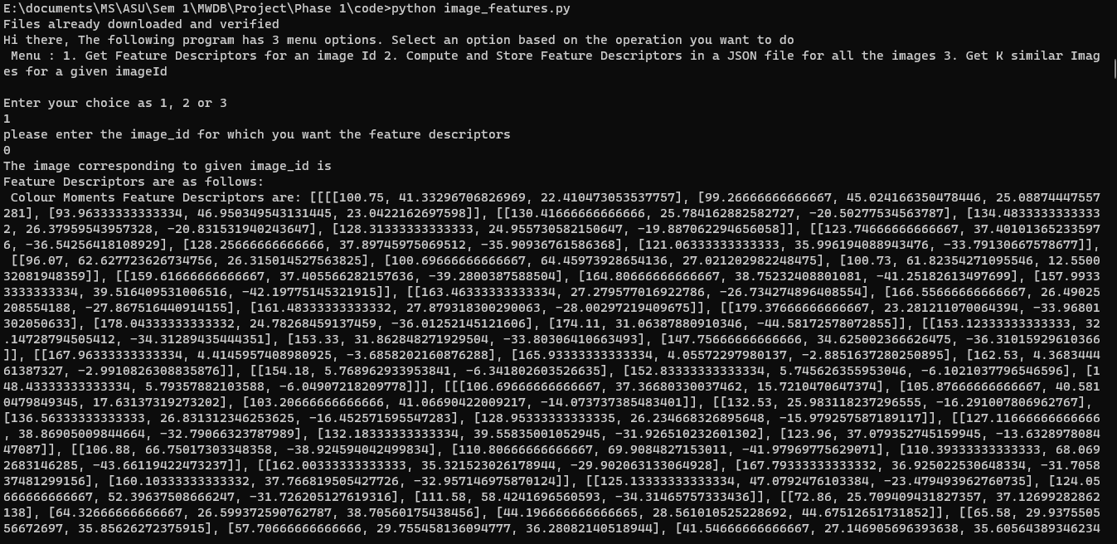

Since, operation 1 is completed, It will again ask you for user input on whether you want to go to menu or exit. To go to the Menu press 1. To exit give 2.

In the Menu, you will get same options as 1. To get Feature Descriptors for a given Image Id 2. To Compute and Store feature descriptors for all images and 3. To retrieve k similar images for a given image.

Now for the 3rd option:

The program will ask for image Id for which the similar images needs to be retrieved. Please provide the image_id. Then the program will ask for number of similar images that needs to be retrieved and please provide the input.

Once input is received the program calculates similarity score for all feature descriptors and prints the image Id and similarity score. The Image will be opened in a python visualizer and the program will halt until you close the image.

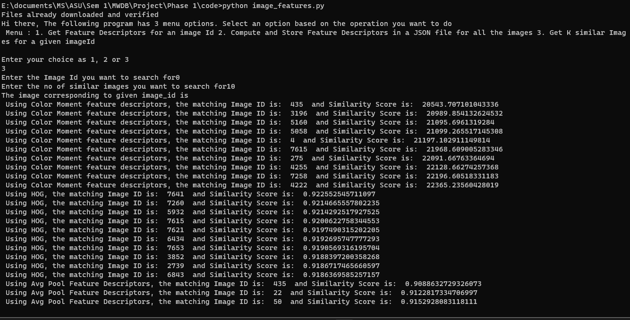

Outputs:

For outputs, please check the output folder, I arranged all the images based on the name in the best similar image. I couldn’t align the images properly in this word document and due to size and time constraints.

1. Color Moments- Image 0:

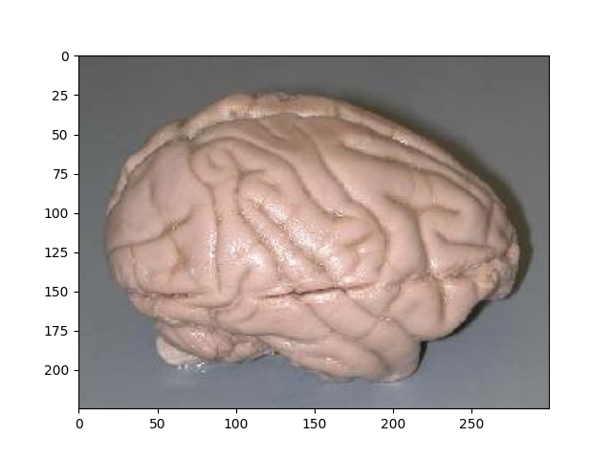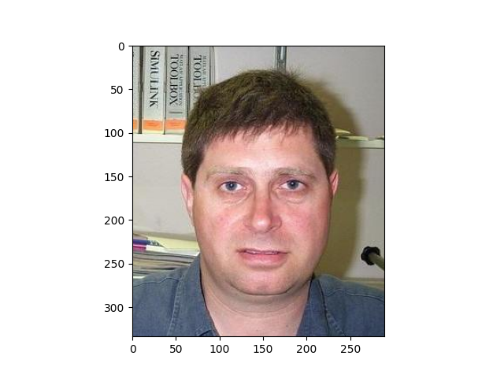

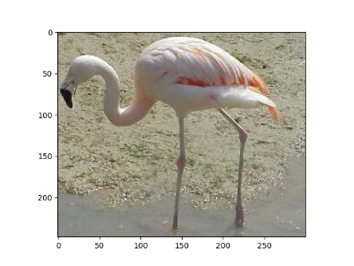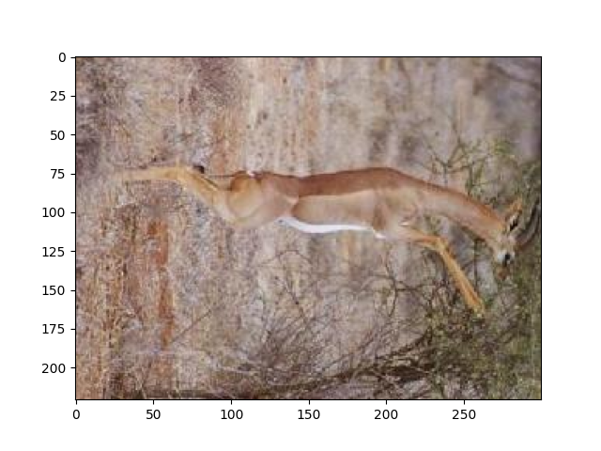

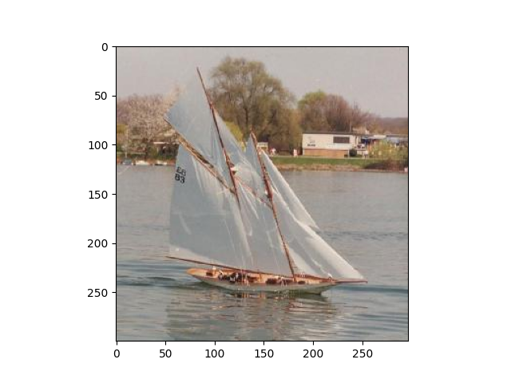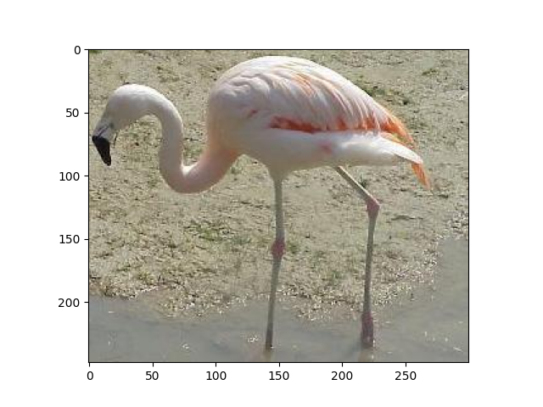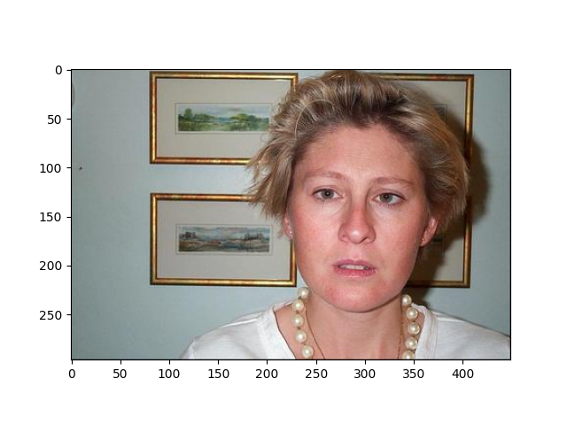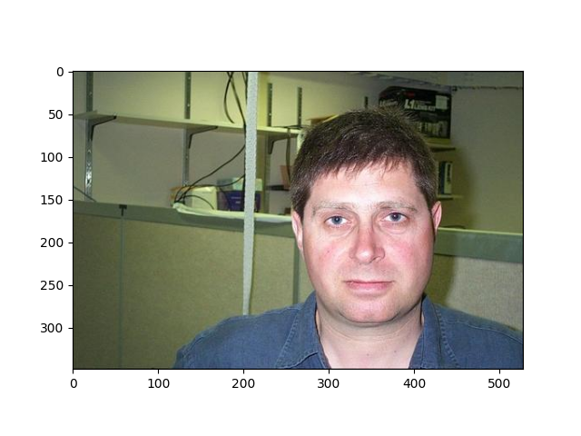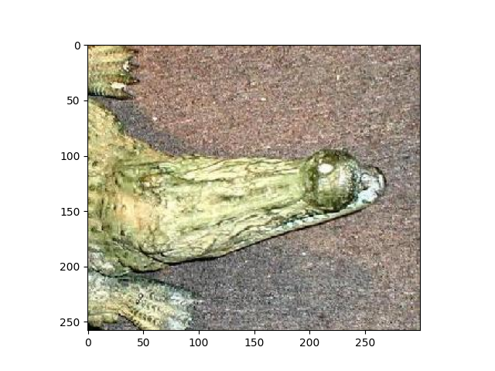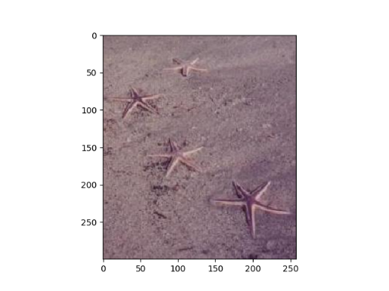

HOG Image: 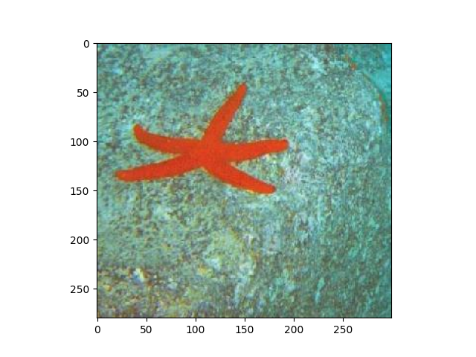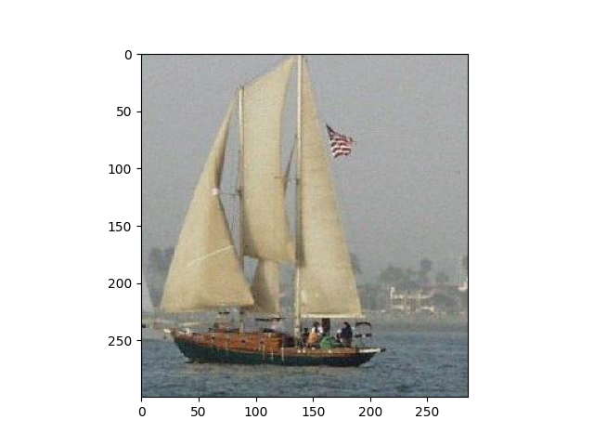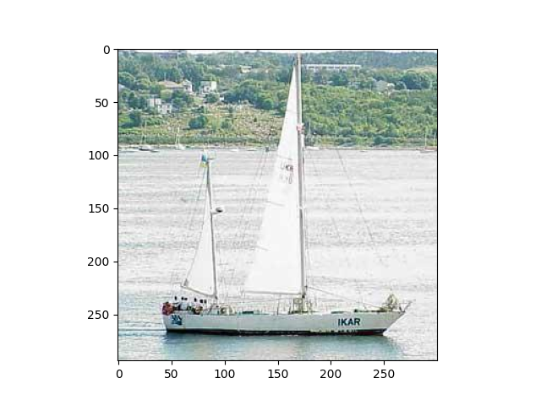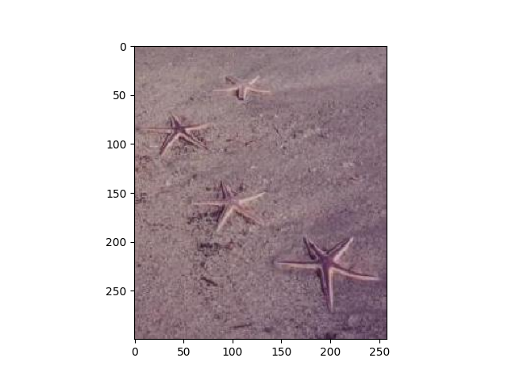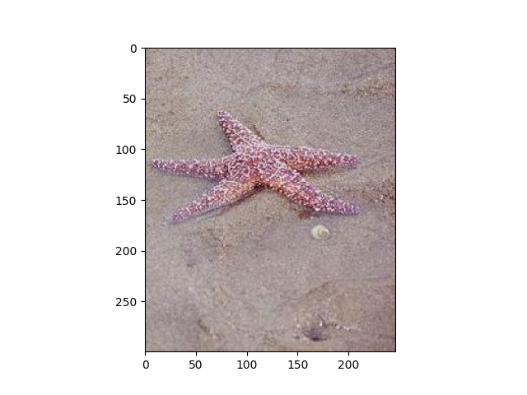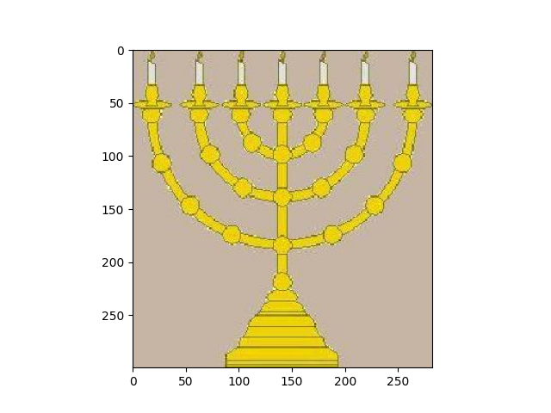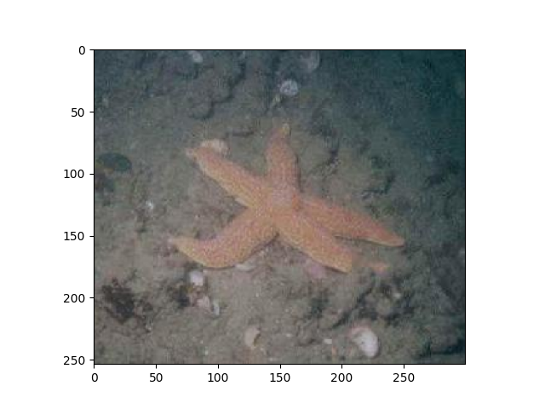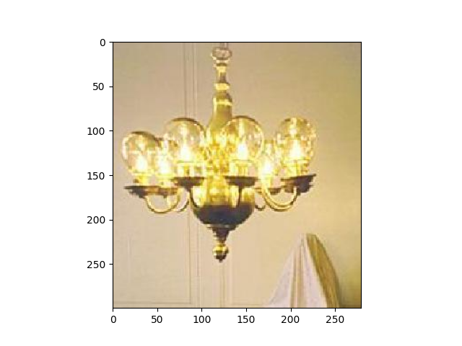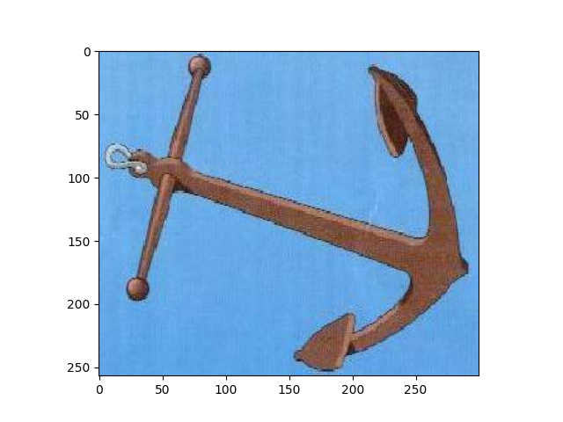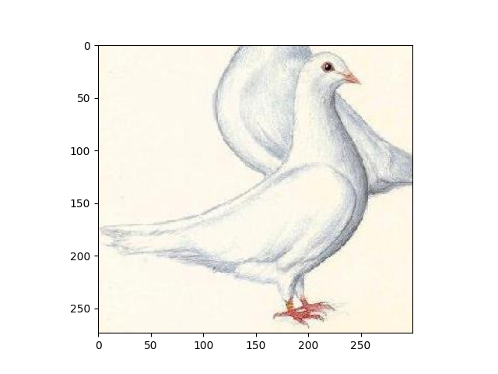

Avg_pool- Image 0:

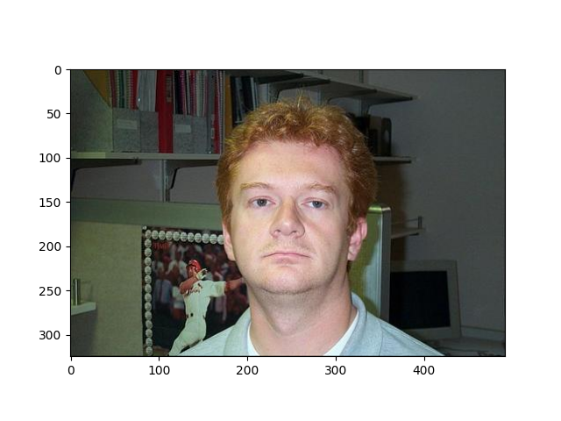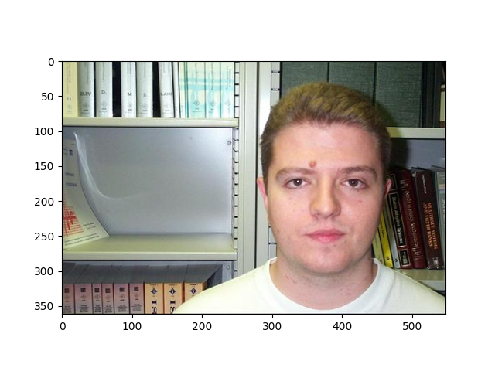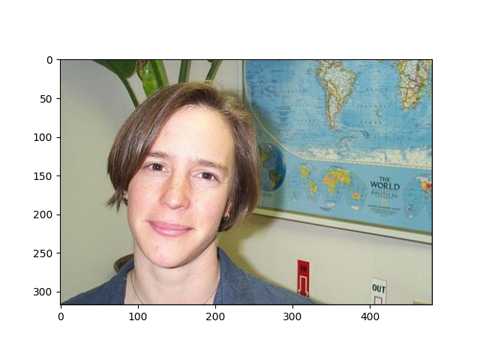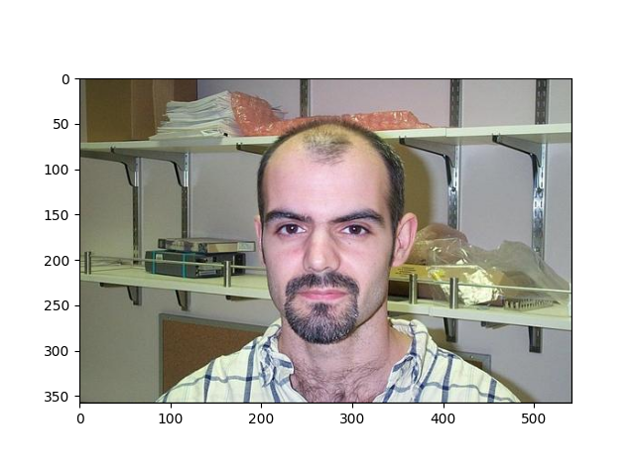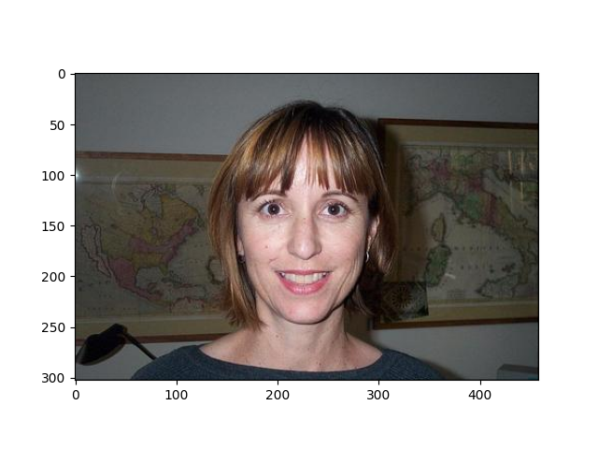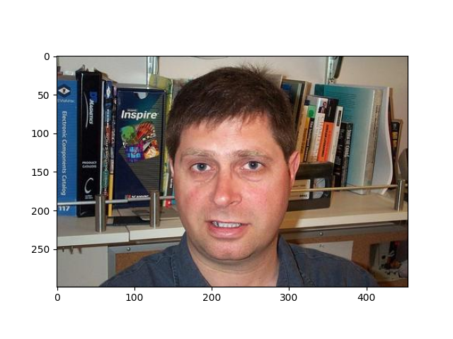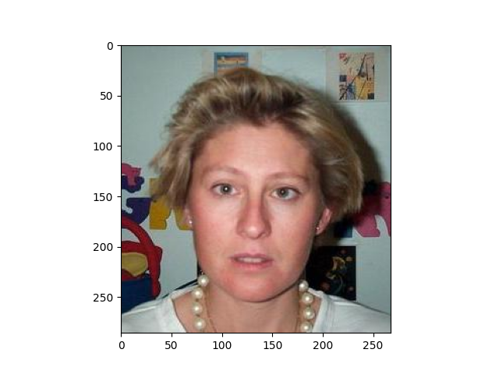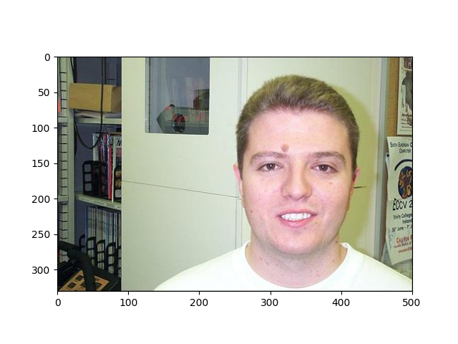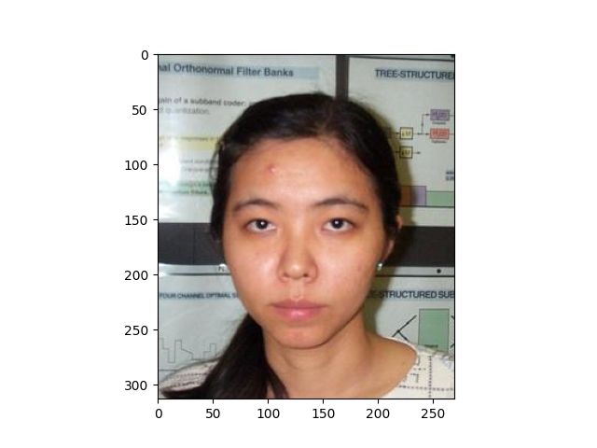

Layer 3:

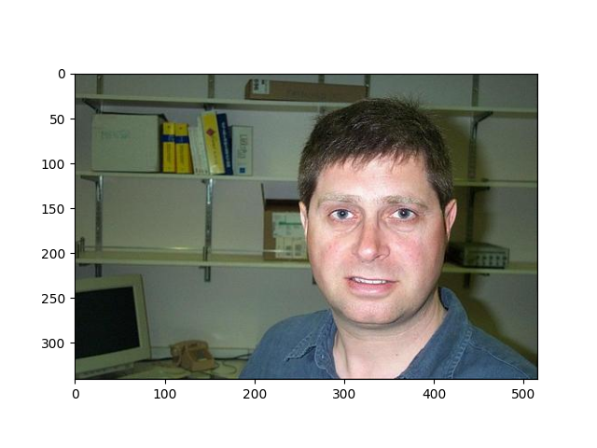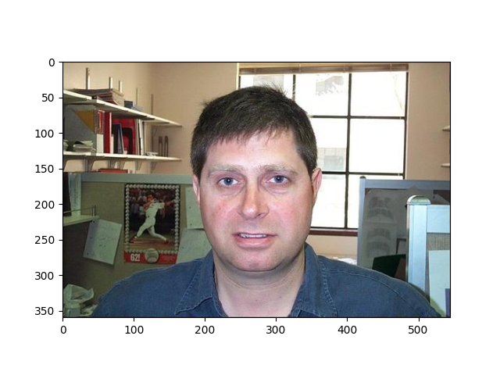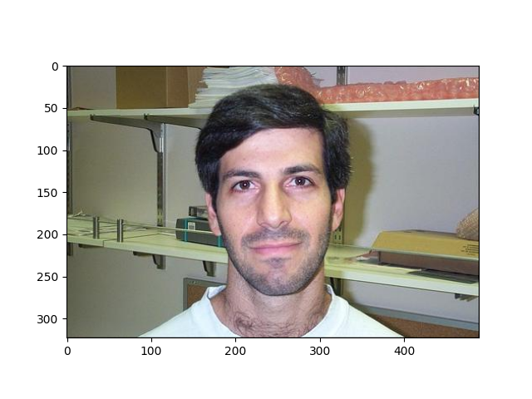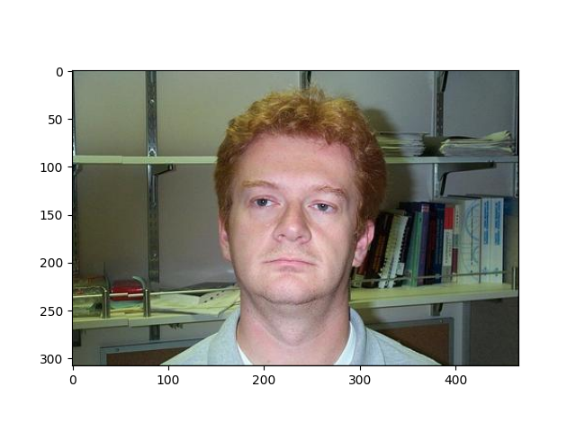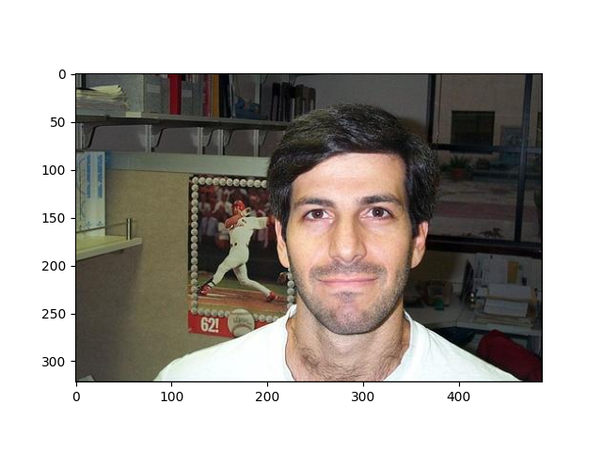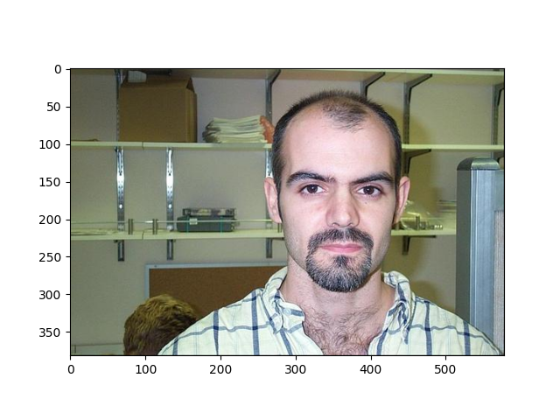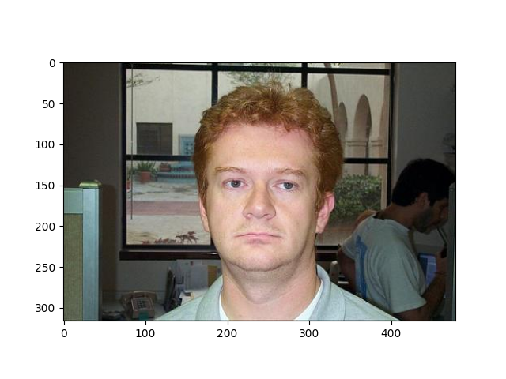

FC- image 0

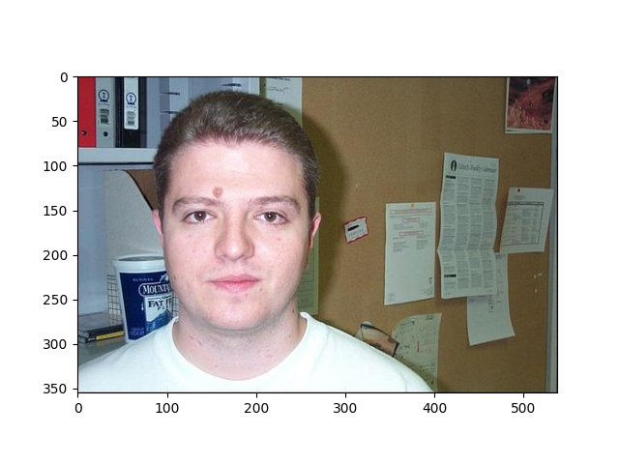

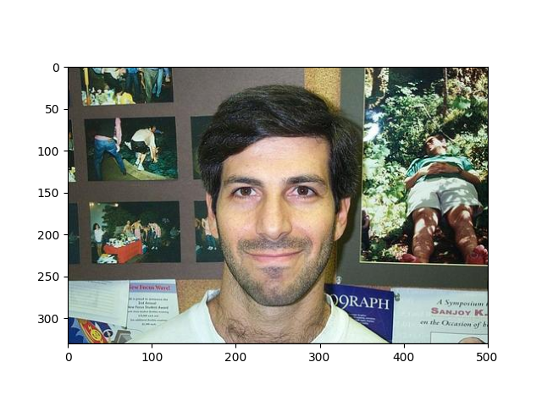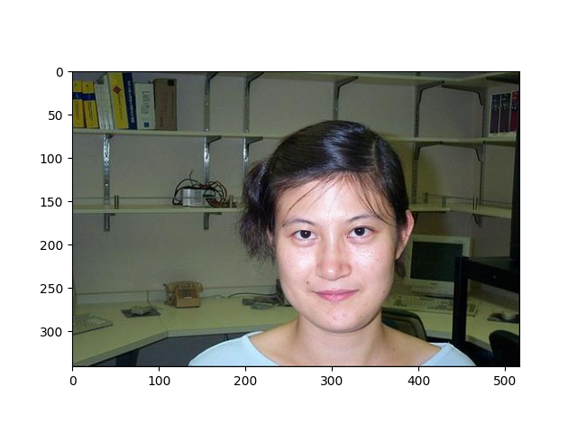

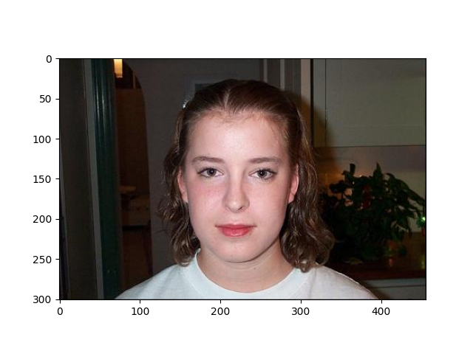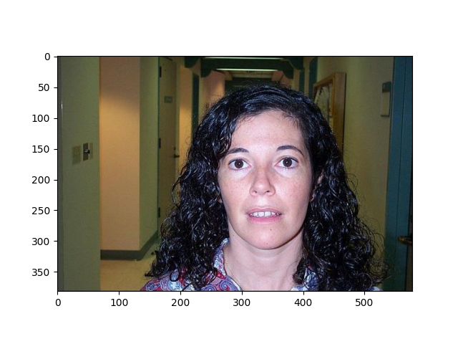

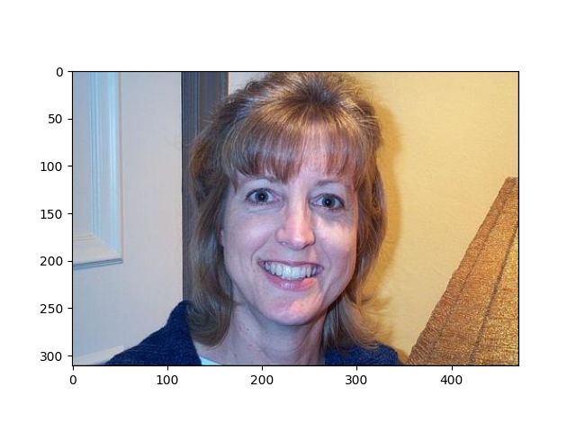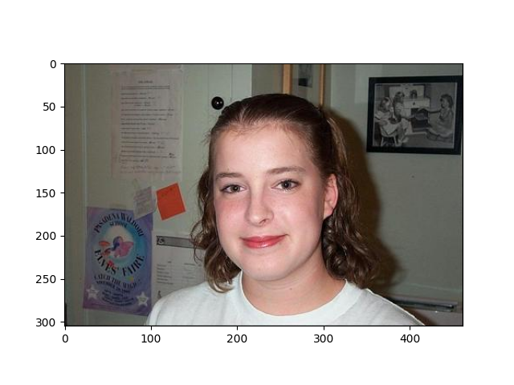

1. Color moments – Image 880:

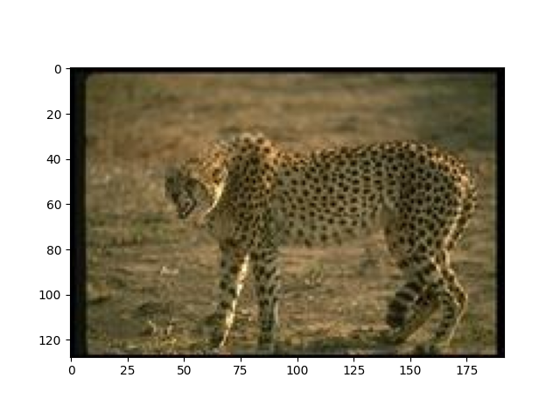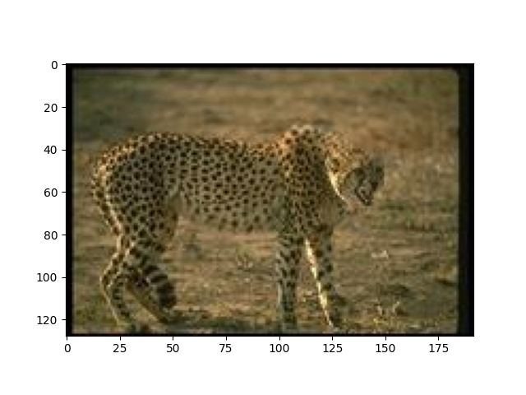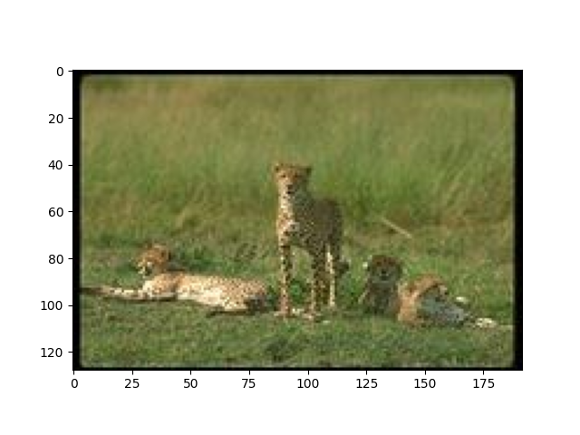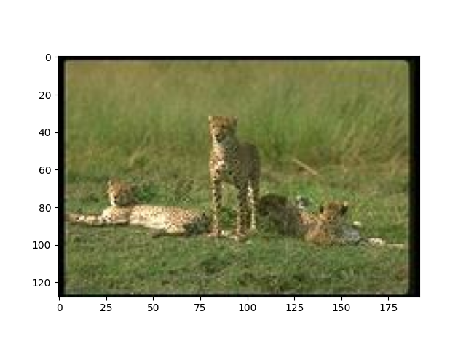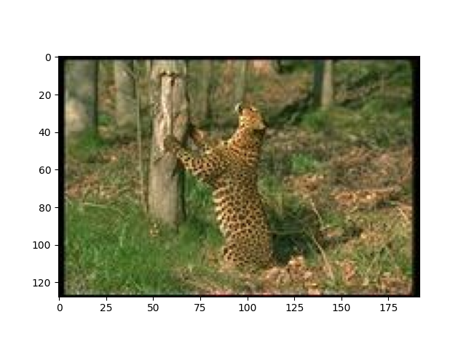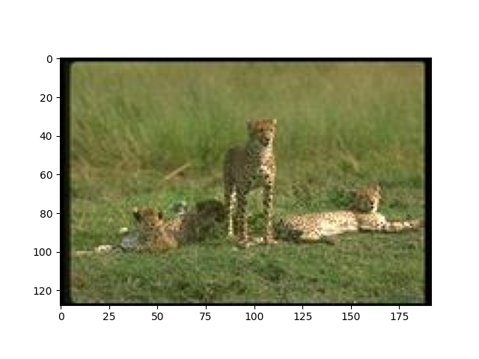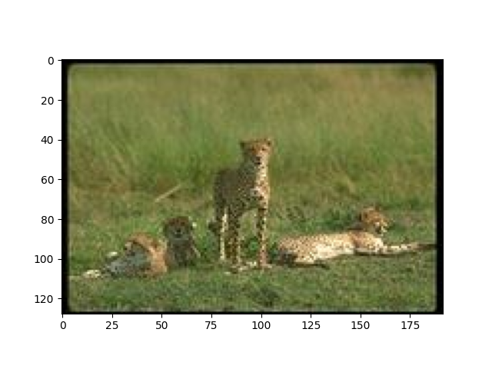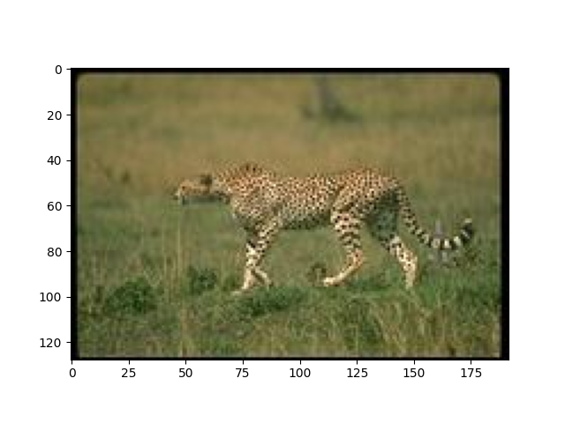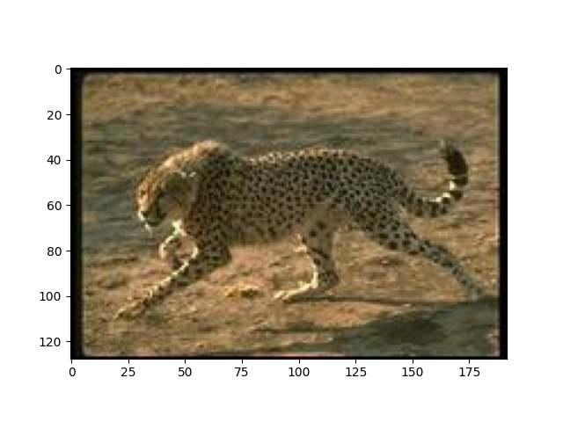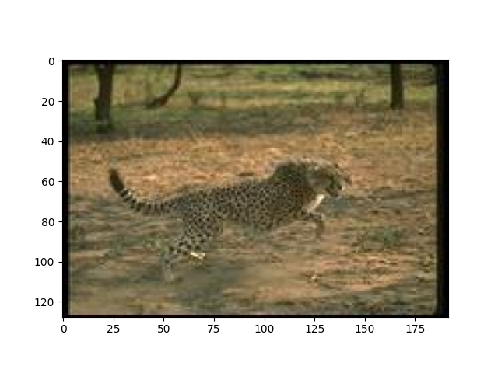

1. 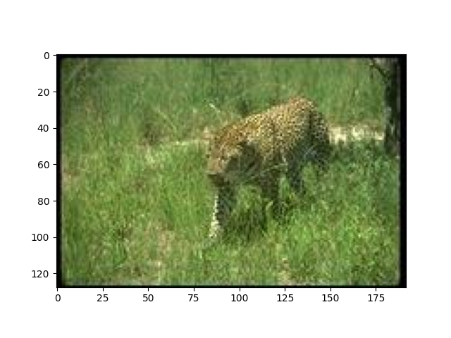HOG – Image 880:

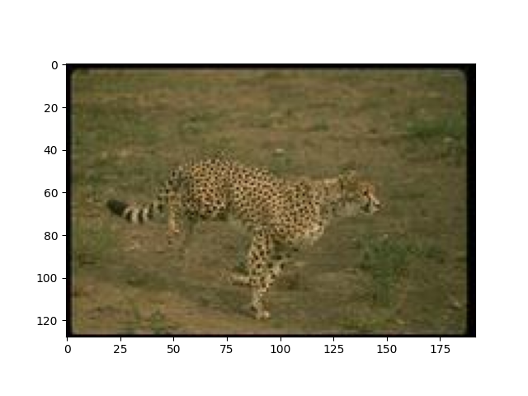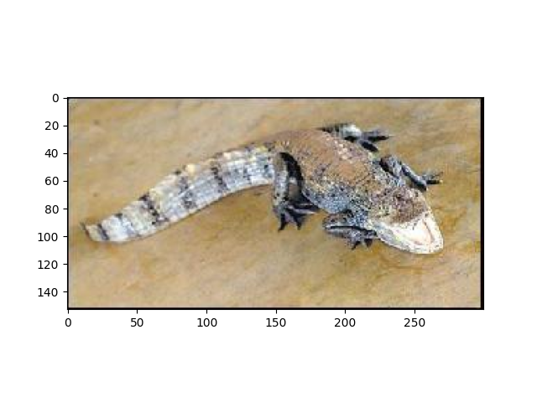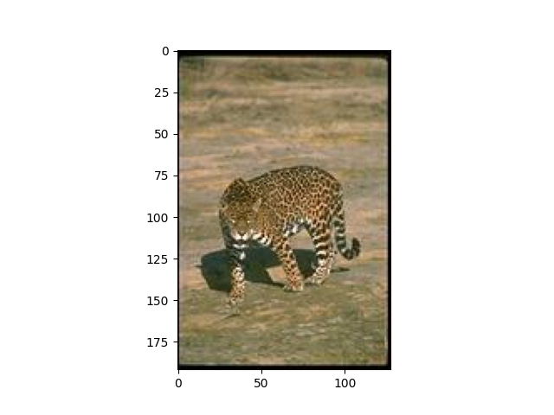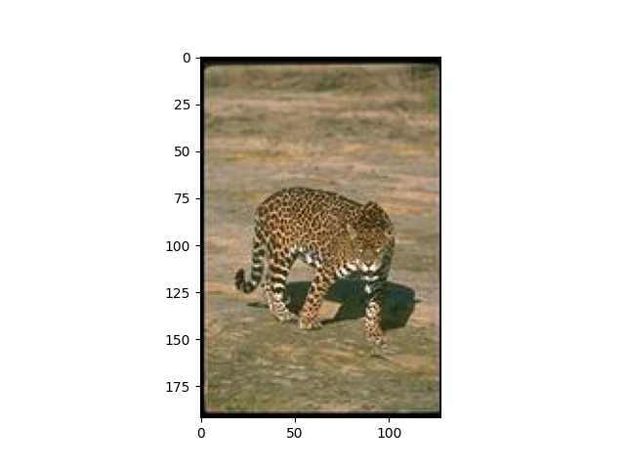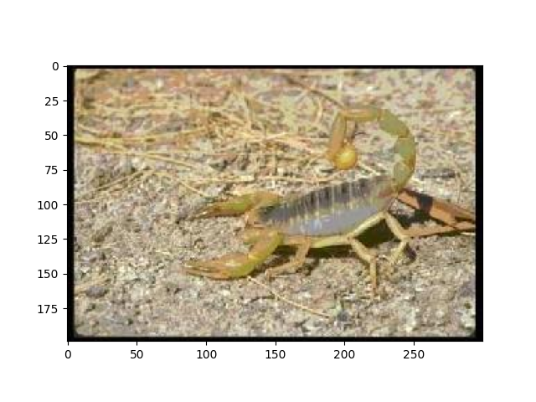

1. Avg Pool Image 880:

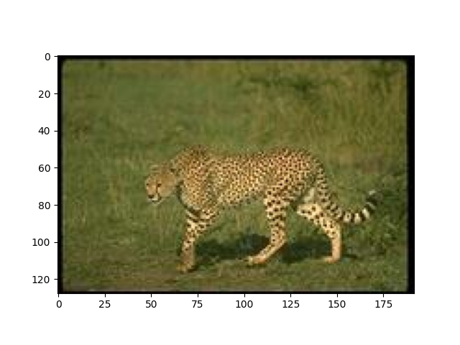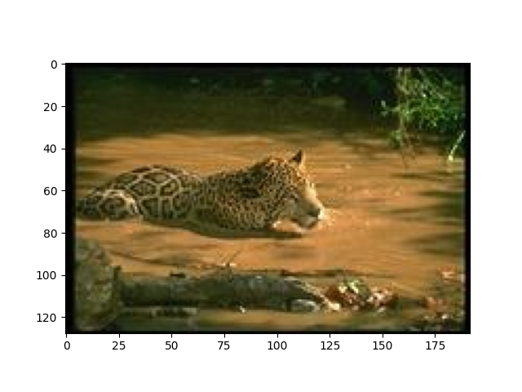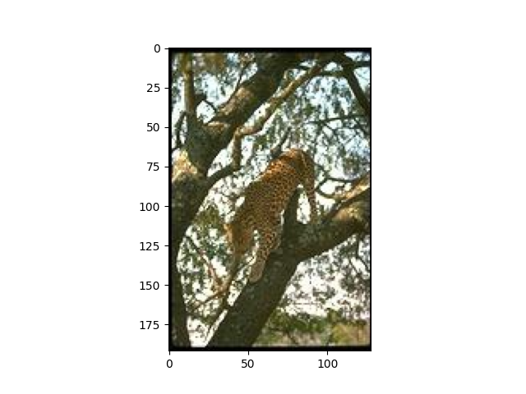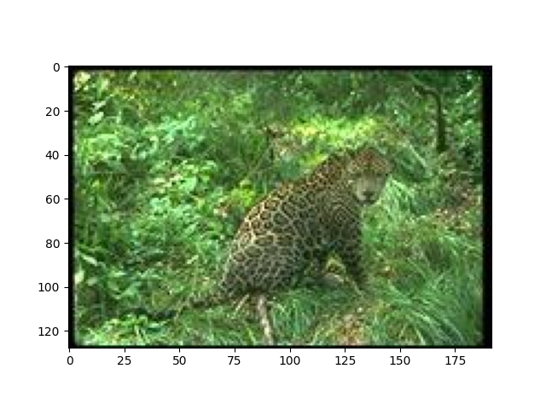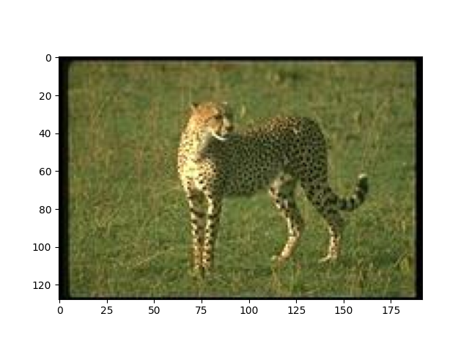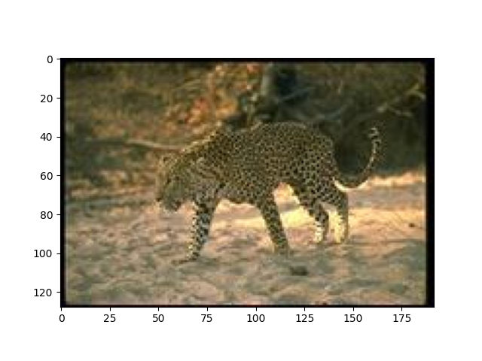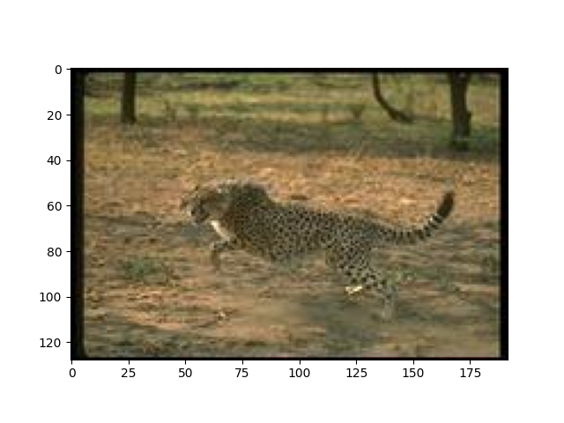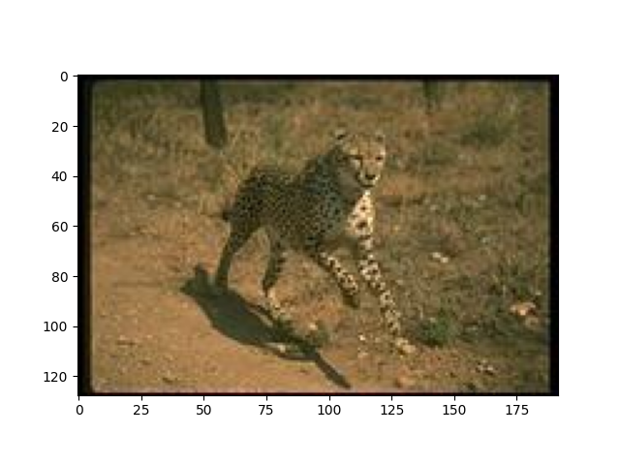

1. Layer 3 – Image 880:

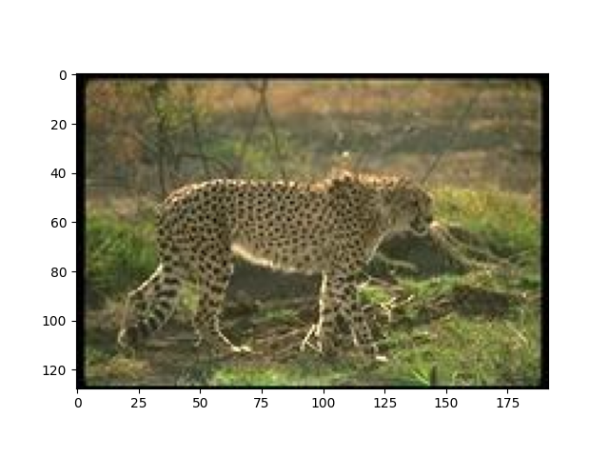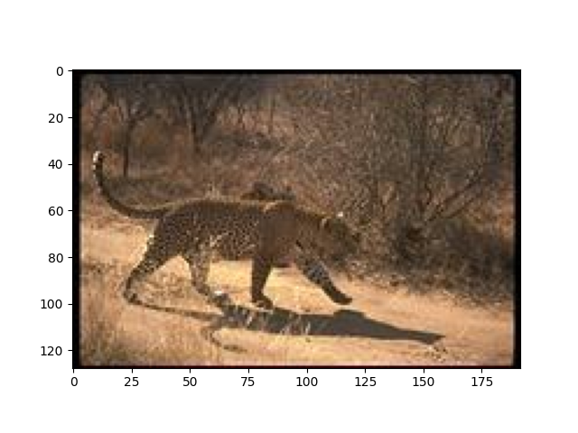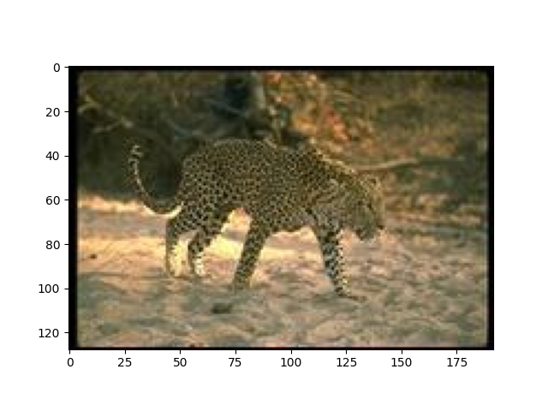

1. FC Image 880 :

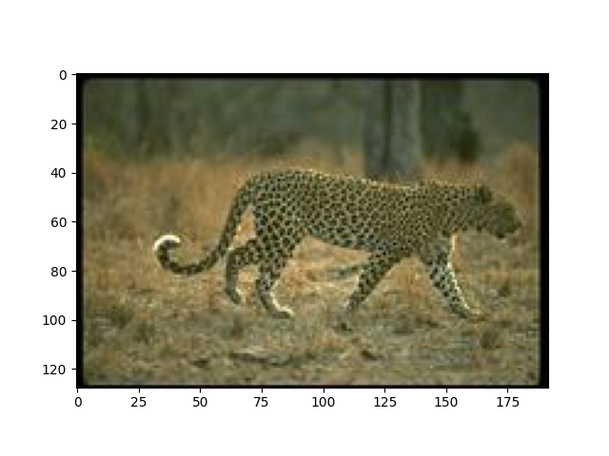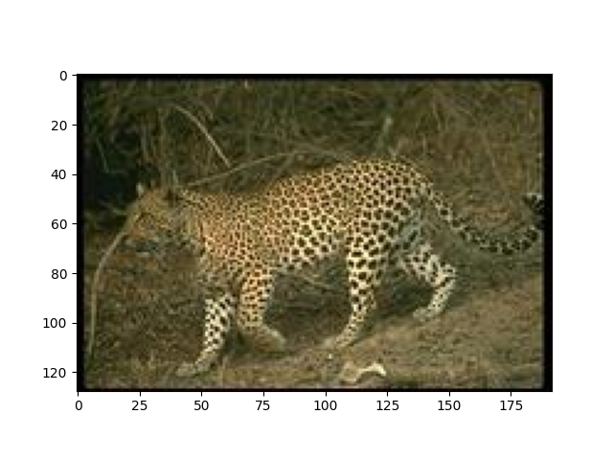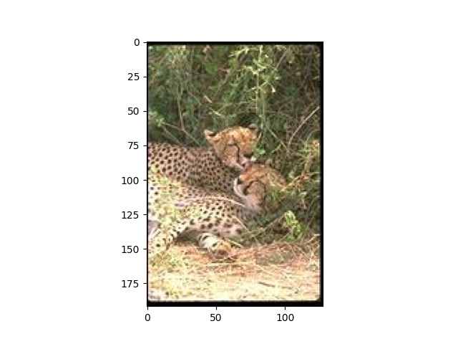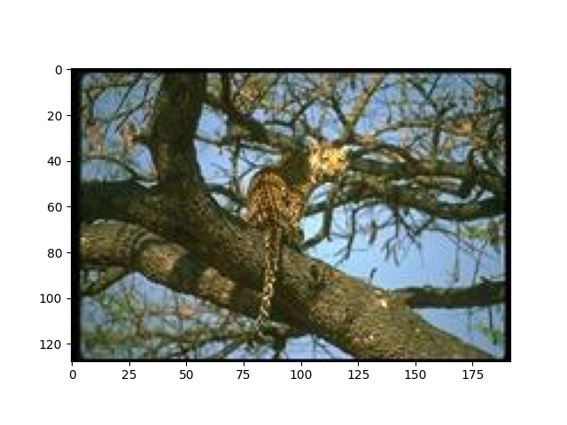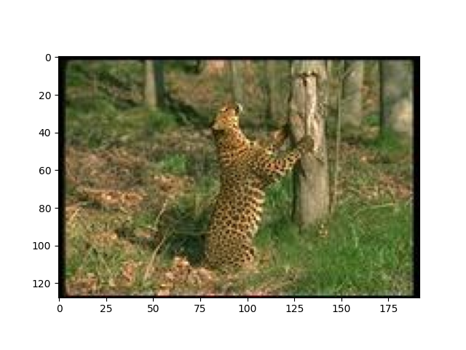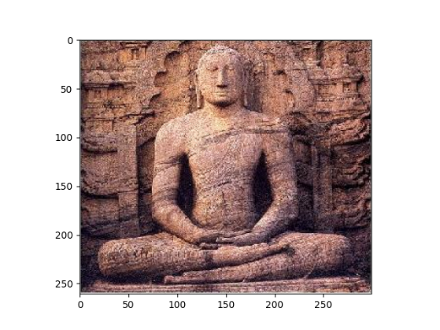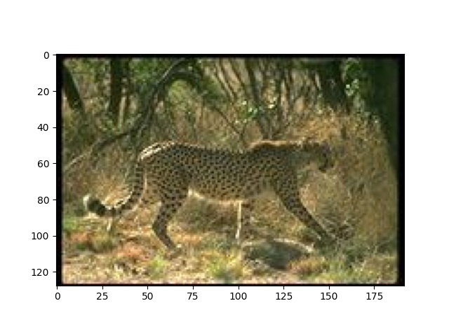

1. 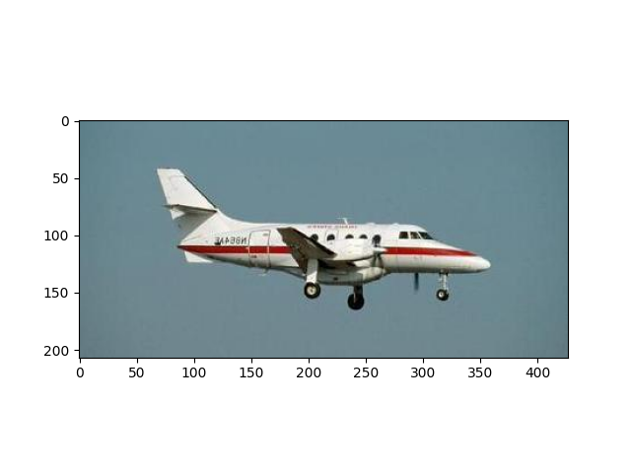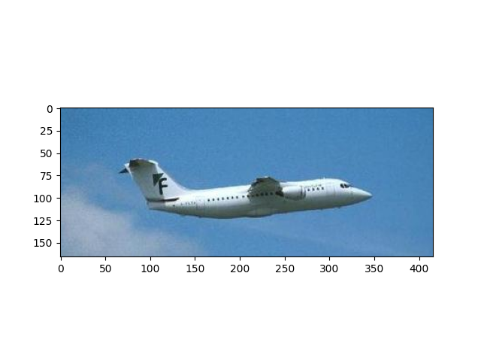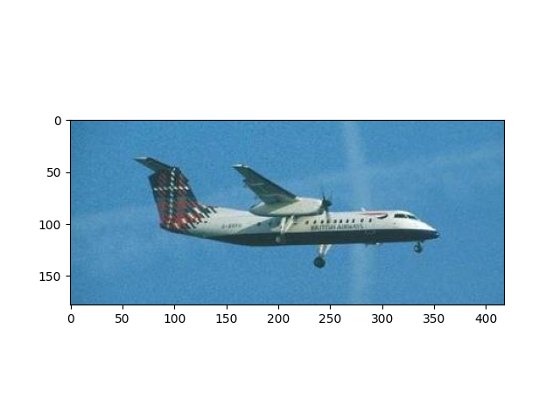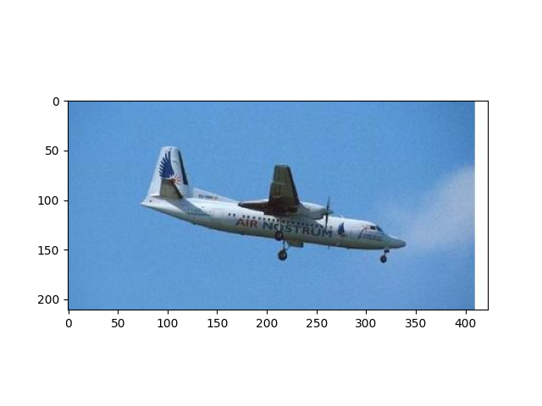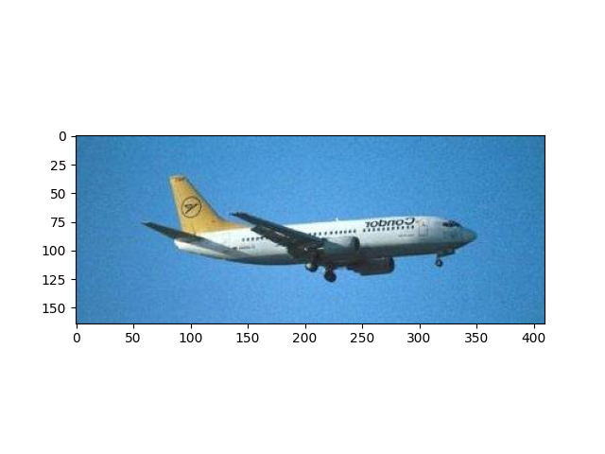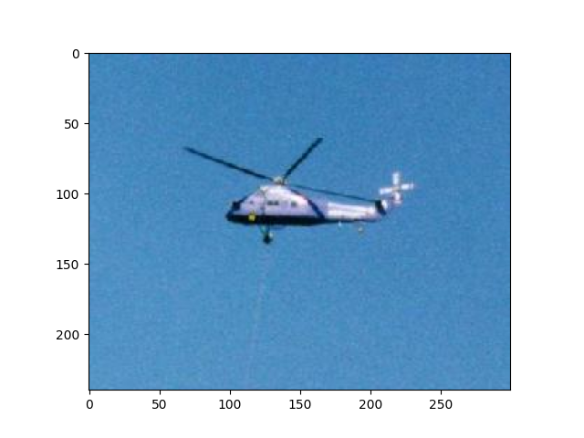Color Moments – Image 2500 :

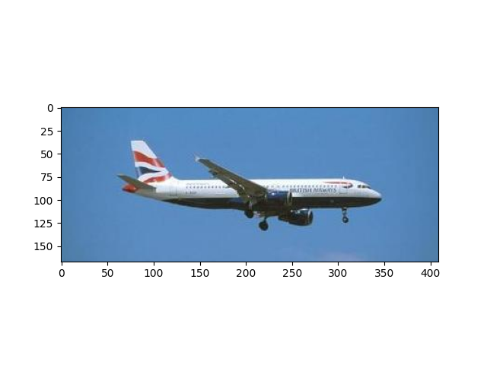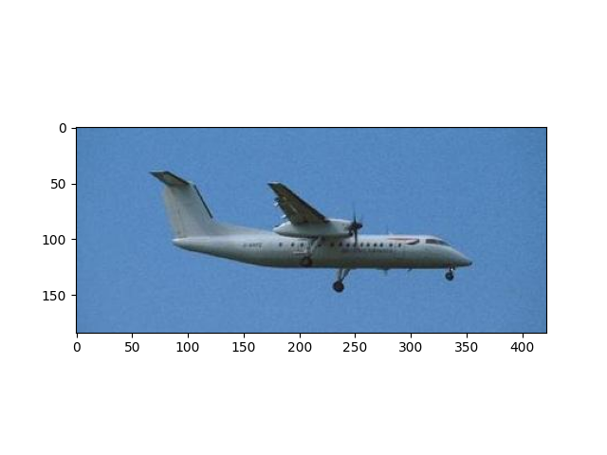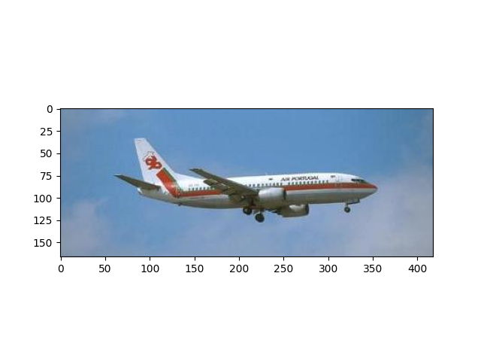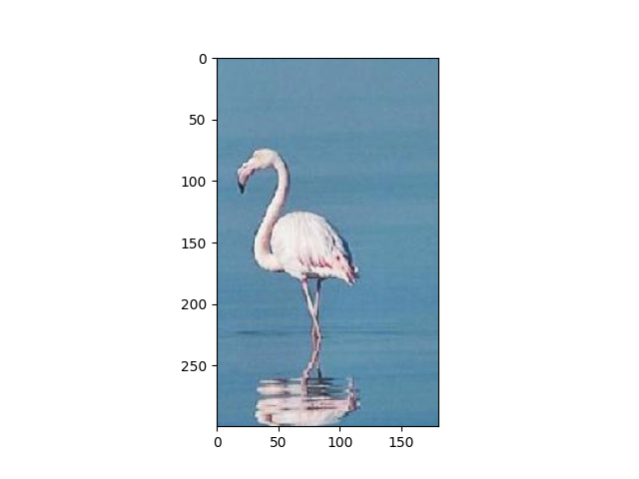

1. HOG- Image 2500:

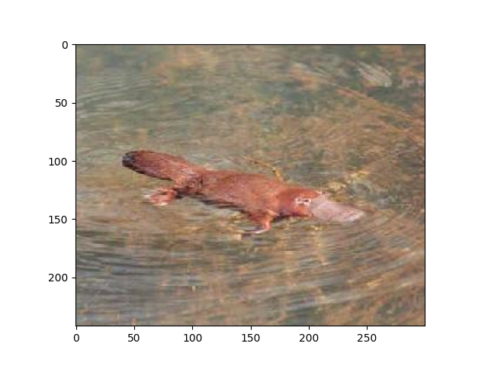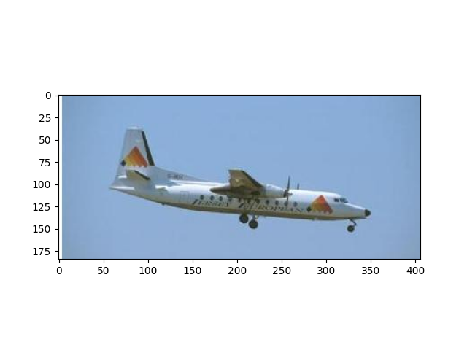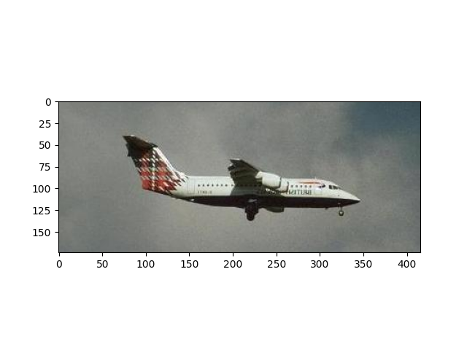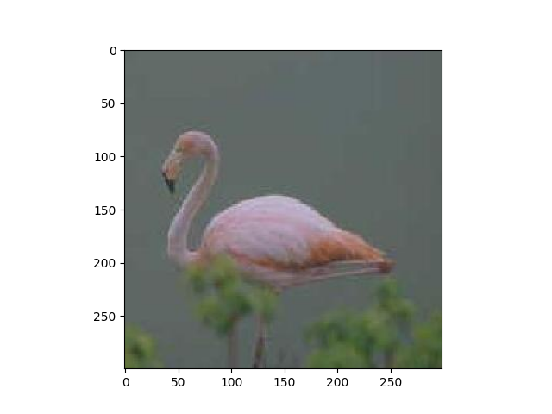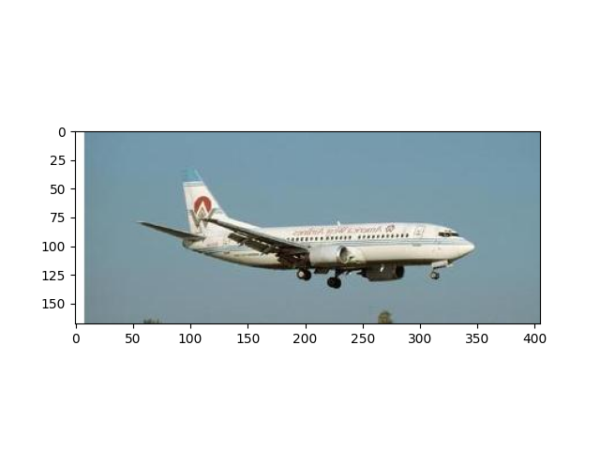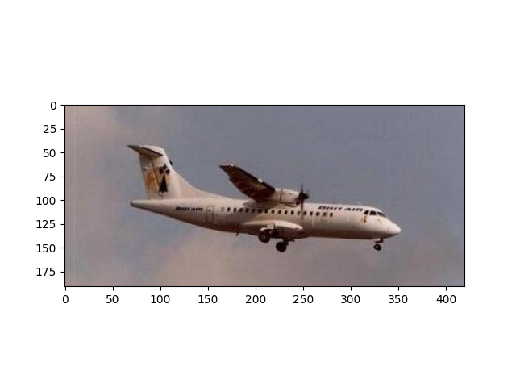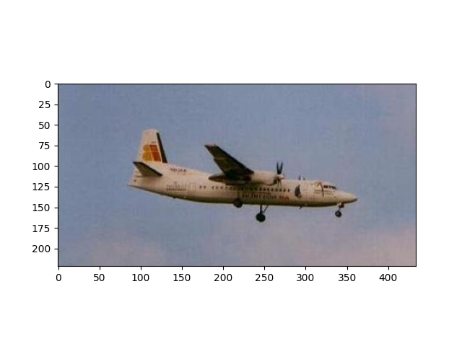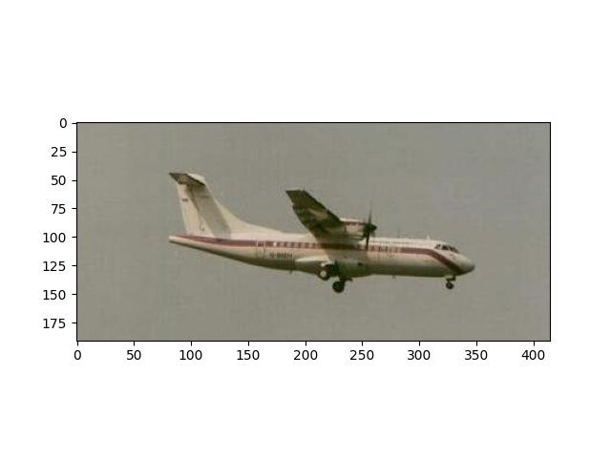

1. 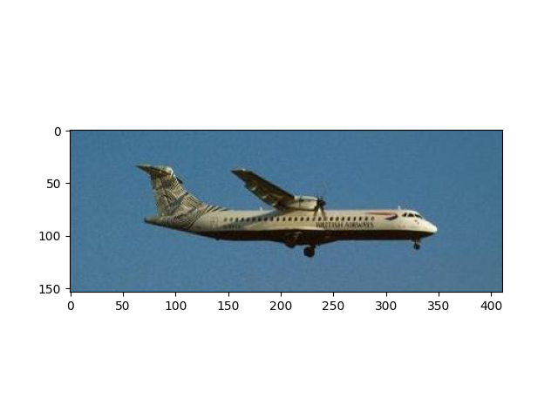Avg_pool – image 2500:

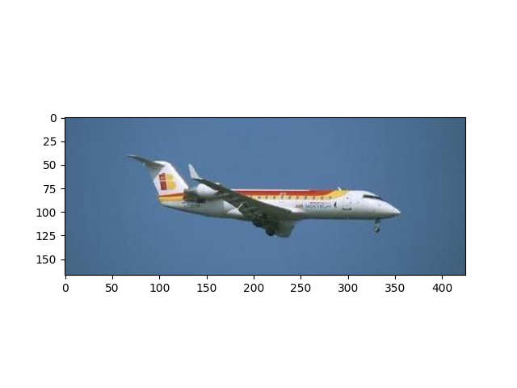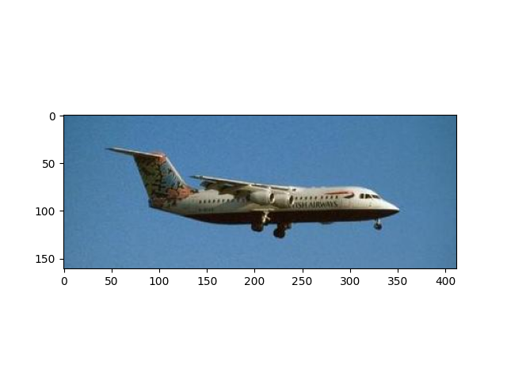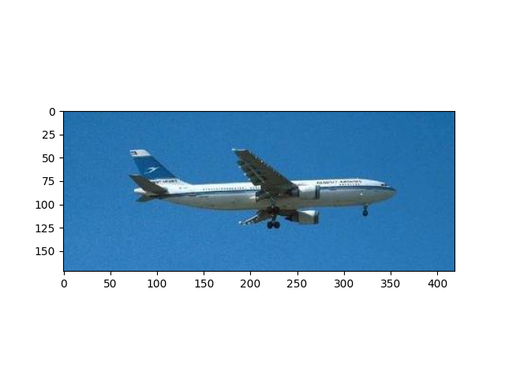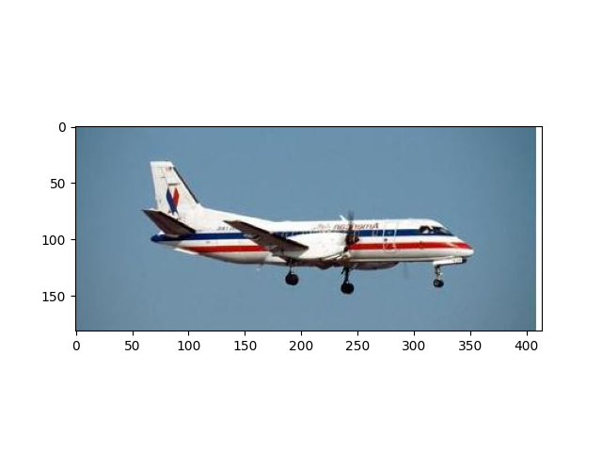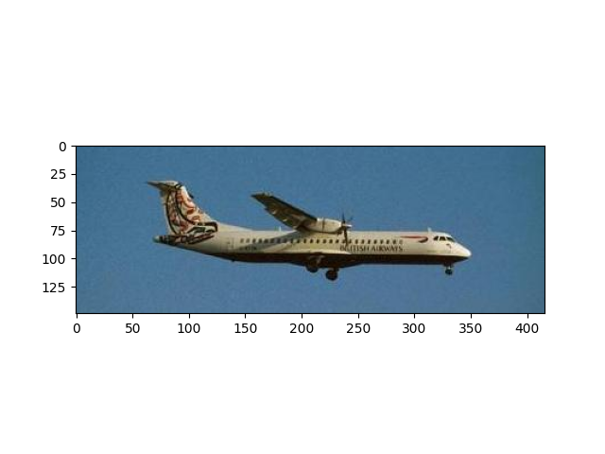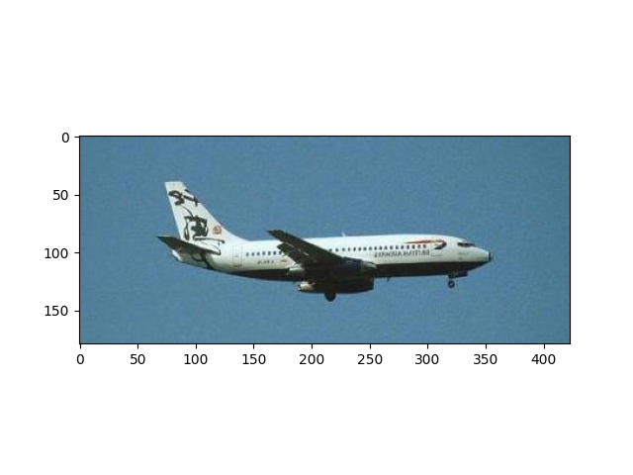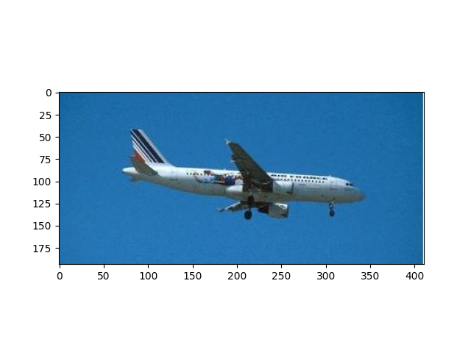

1. Layer 3 – Image 2500:

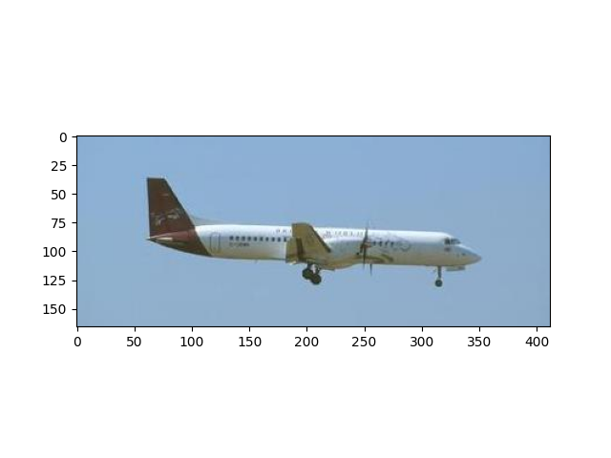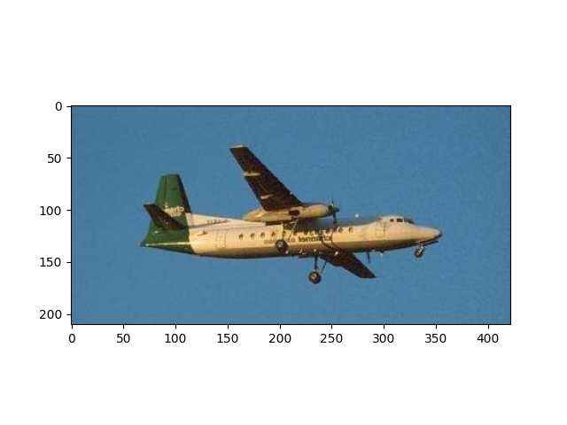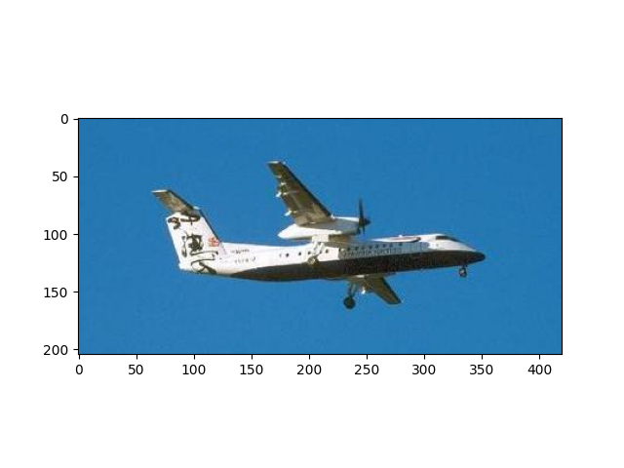

1. FC- Image 2500

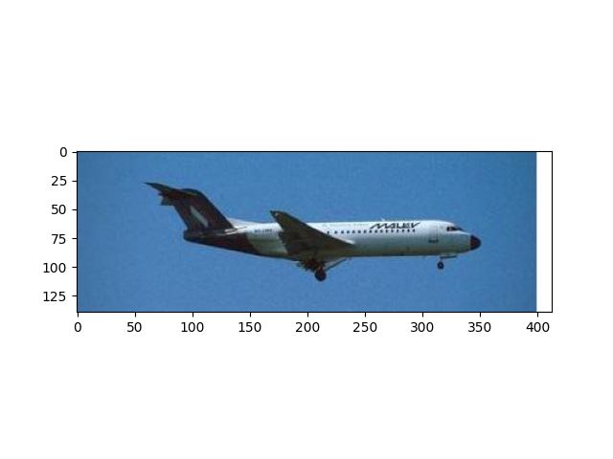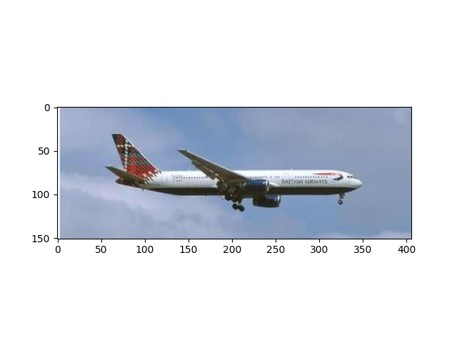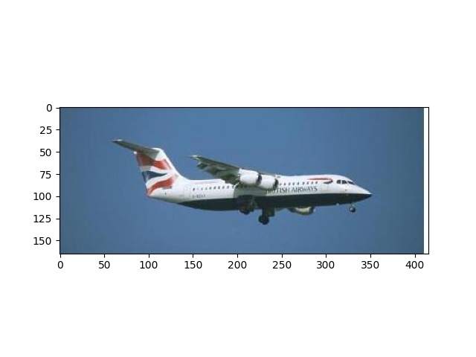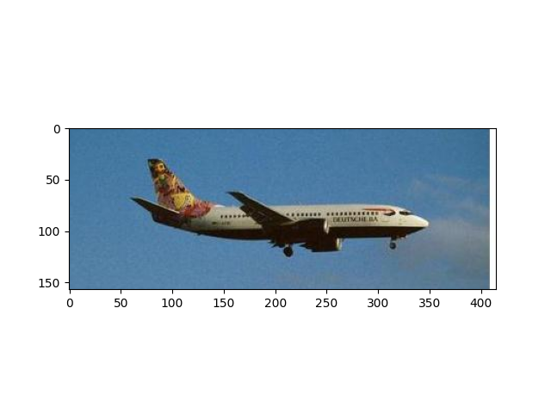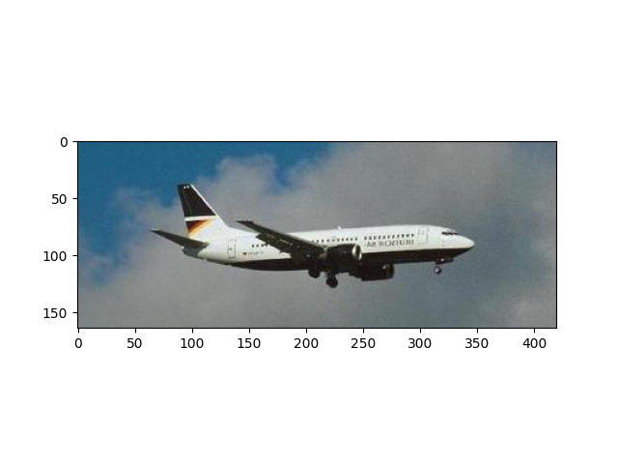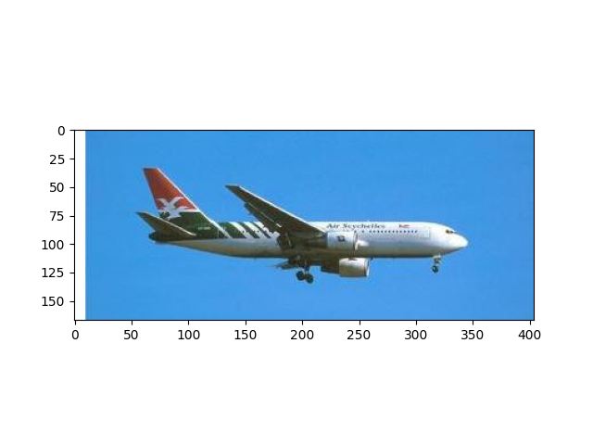

1. Color moments-Image 5122:

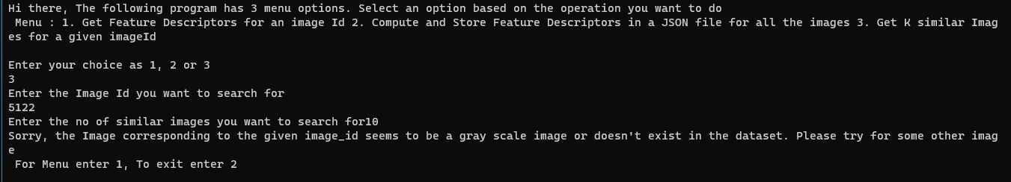

1. HOG- Image 5122:



1. Avg_pool-Image 5122:



1. Layer 3 – Image 5122:



1. FC-Image 5122:



1. Color Moments- Image 8676:

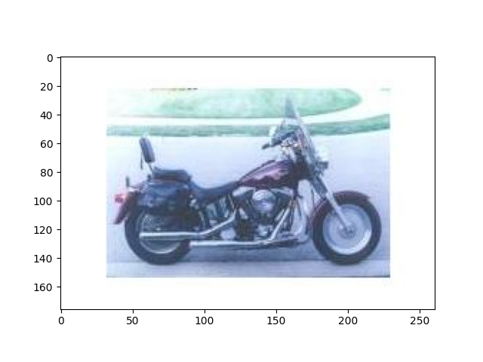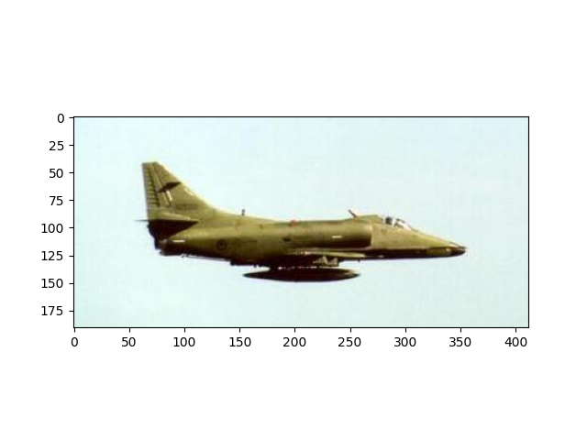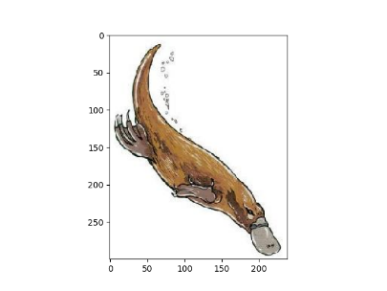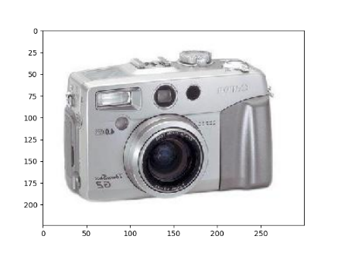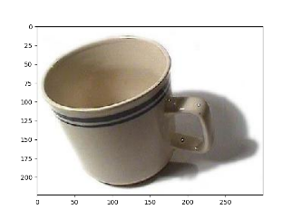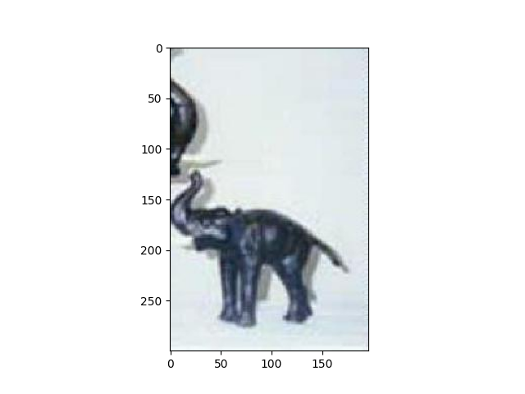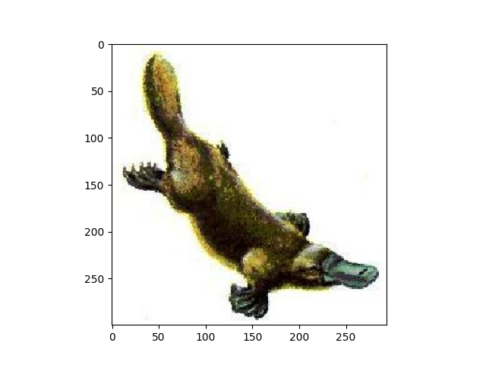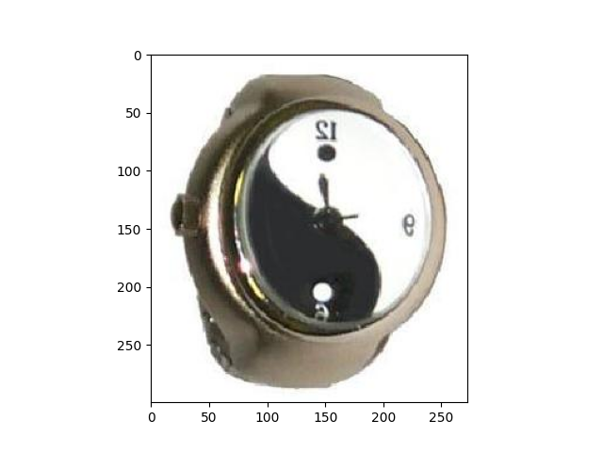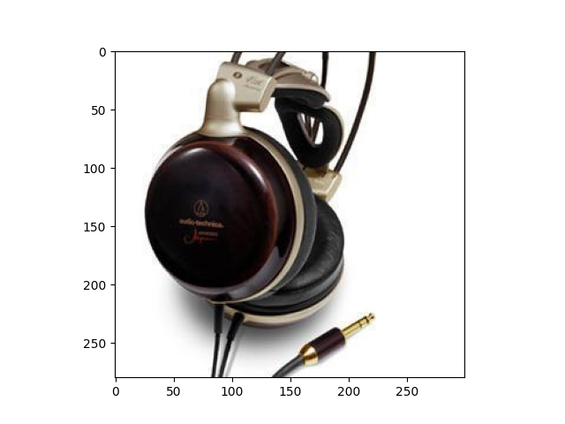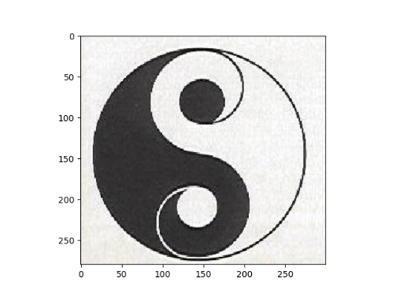

1. 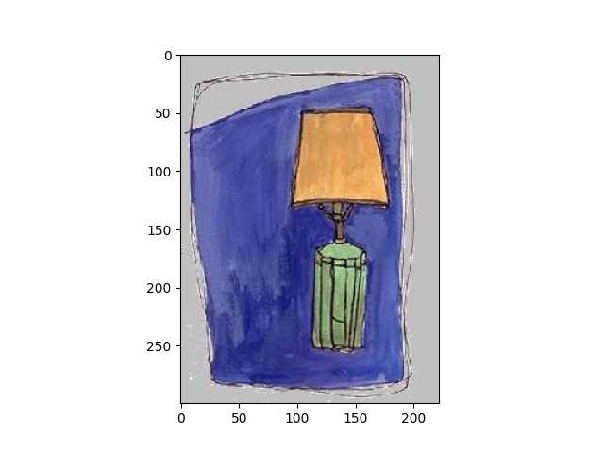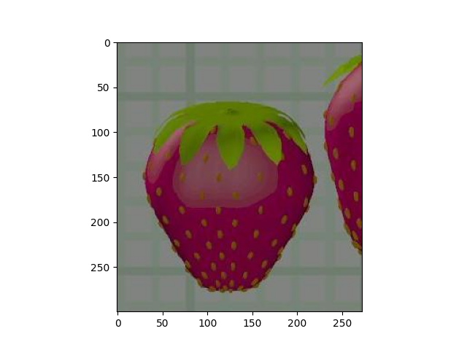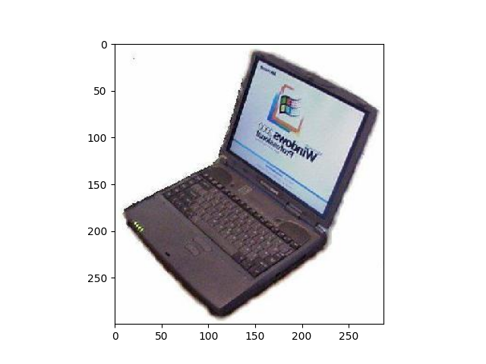HOG – Image 8676:

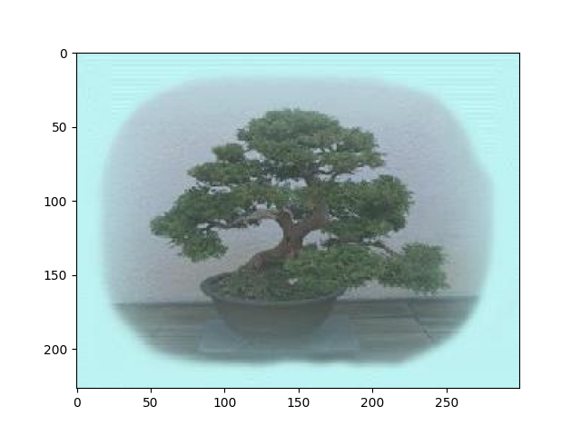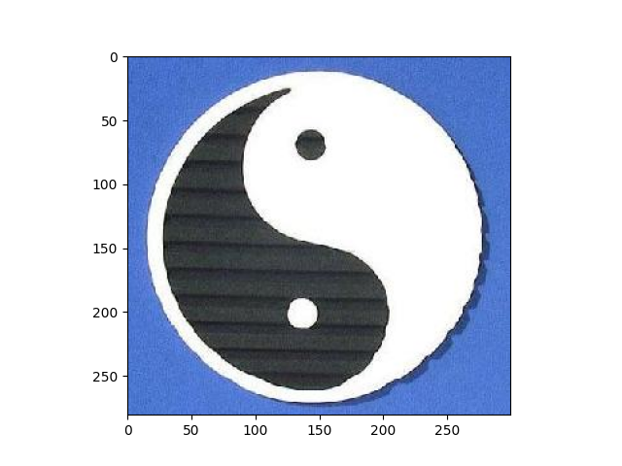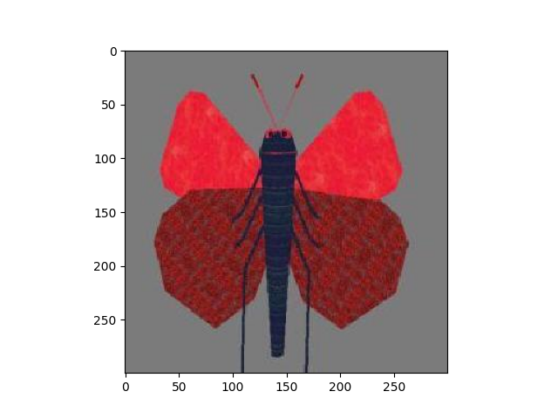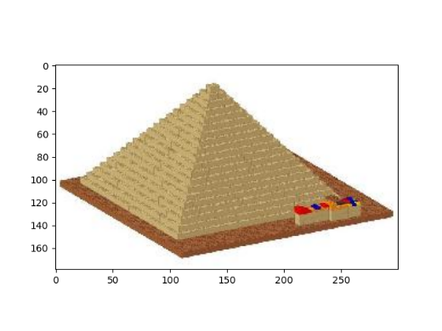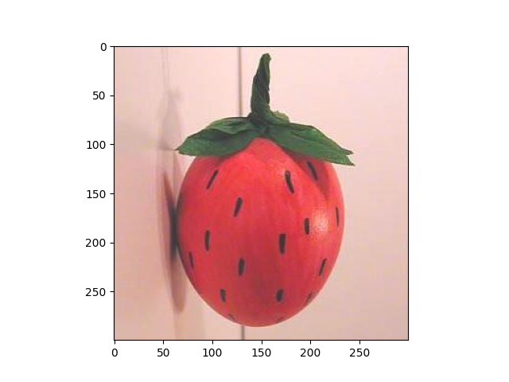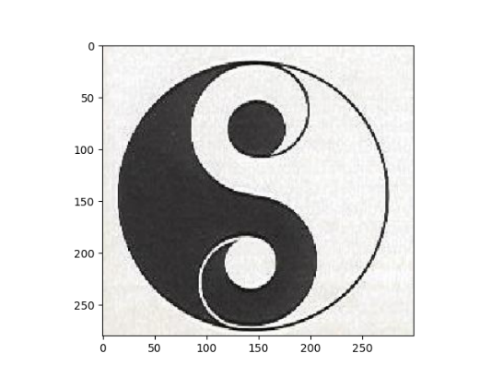

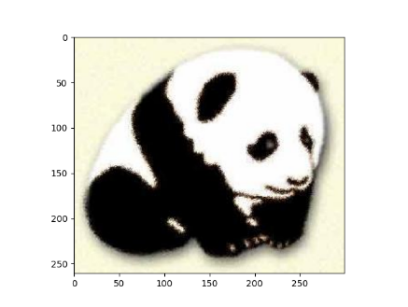

1. 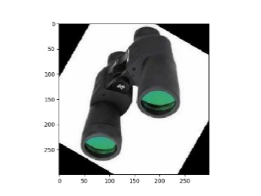Avg_pool -Image 8676:

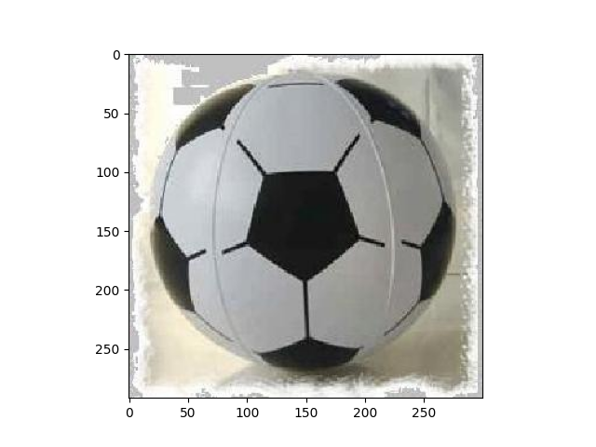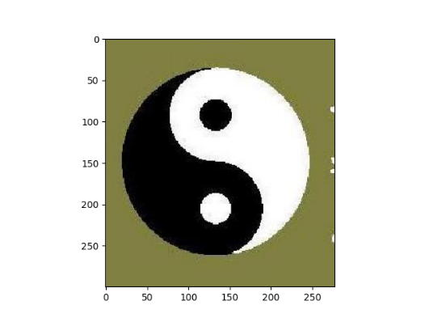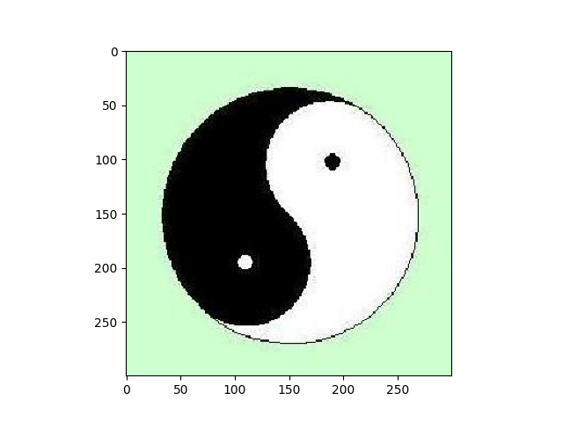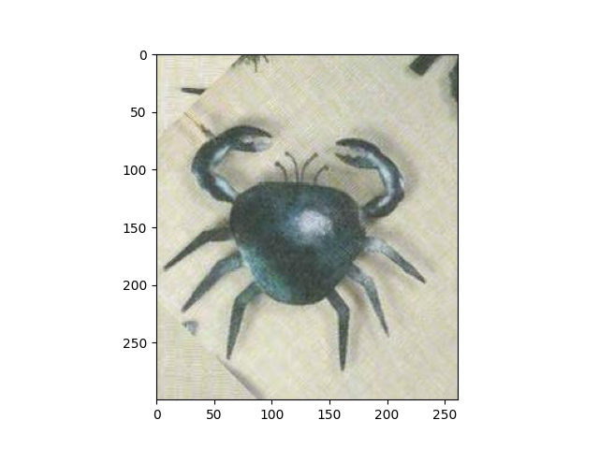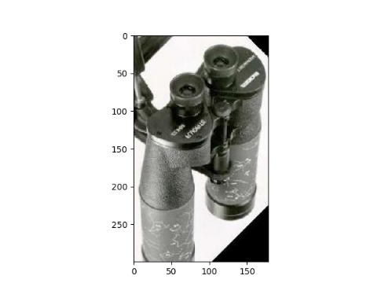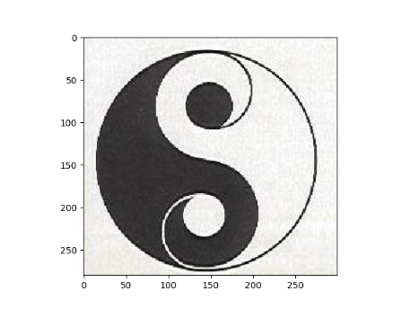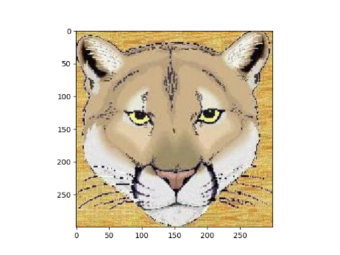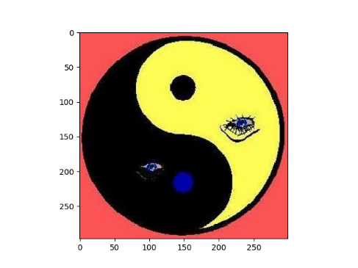

1. 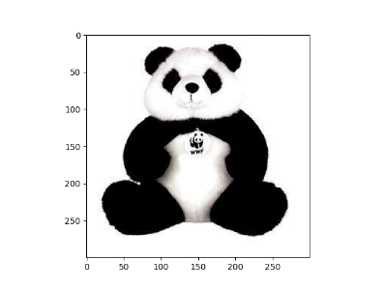Layer 3 – Image 8676:

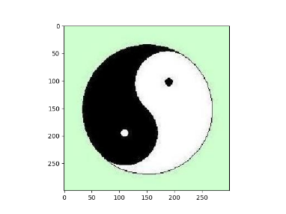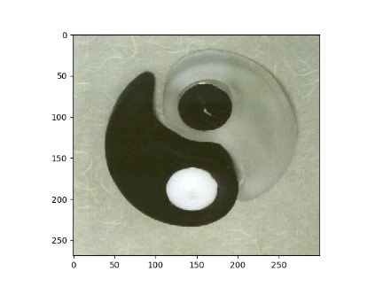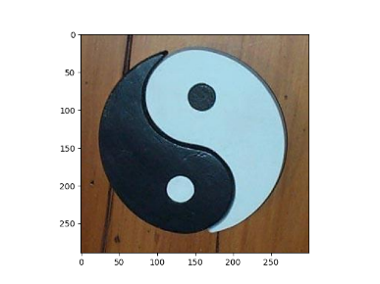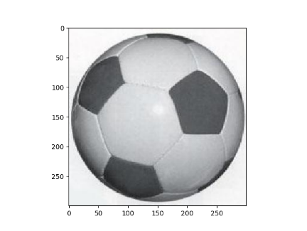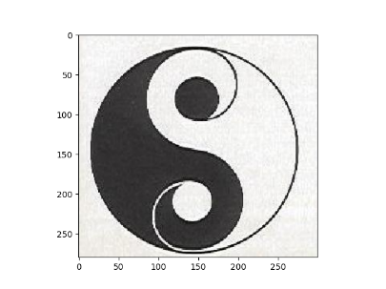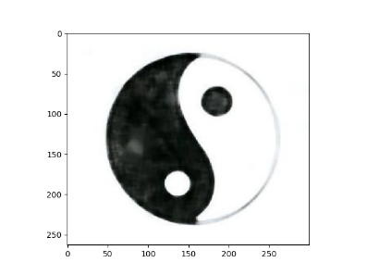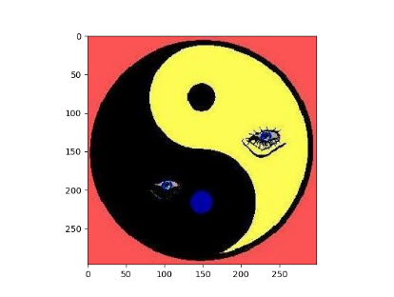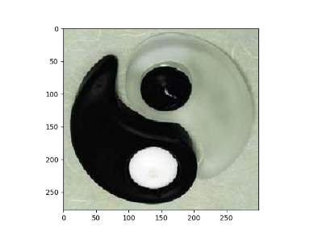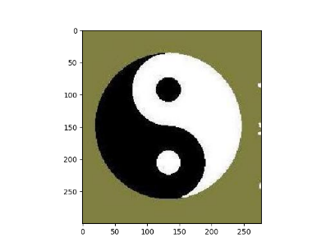

1. FC – Image 8676:

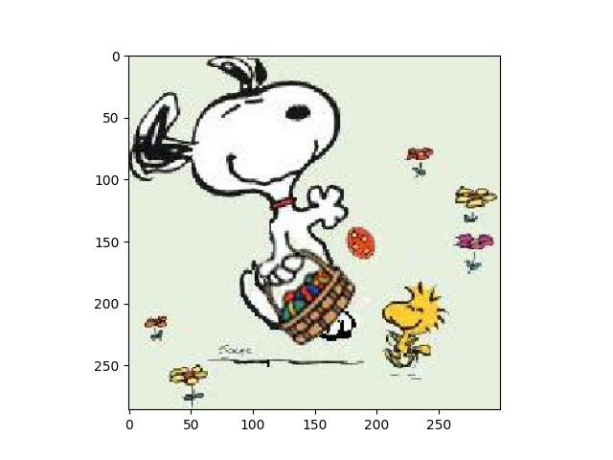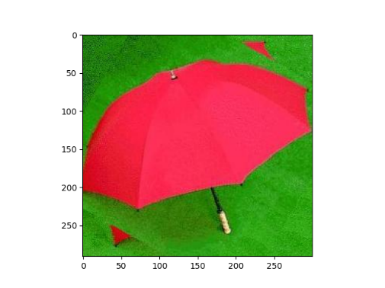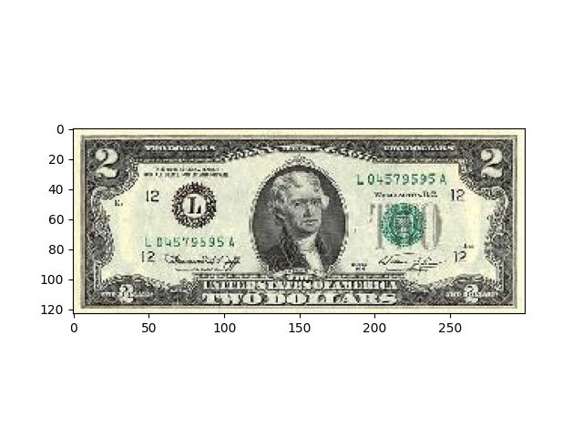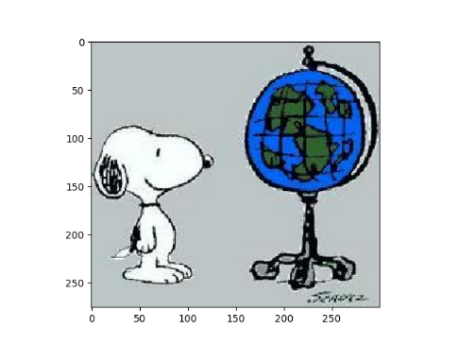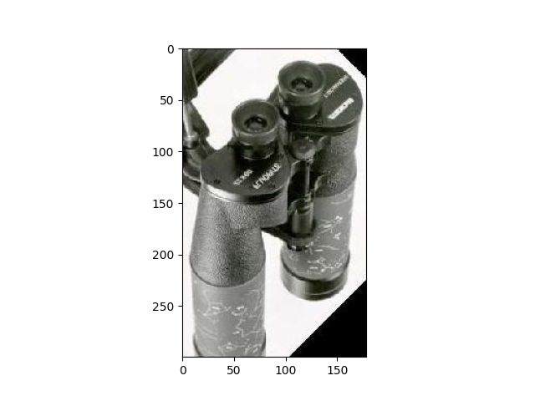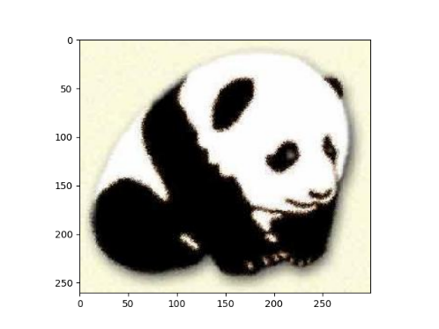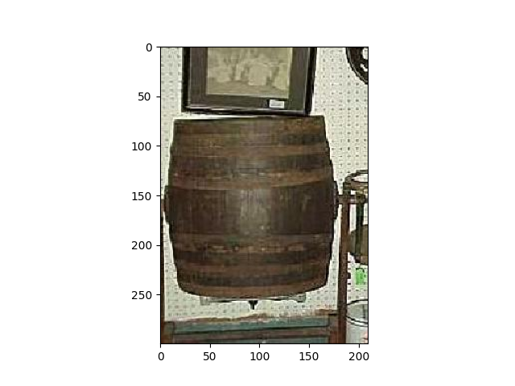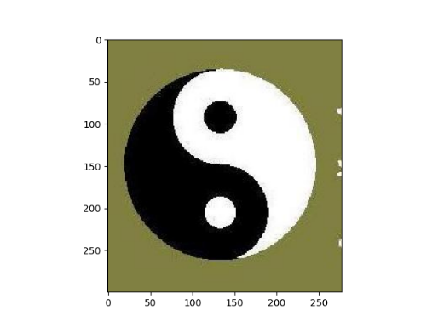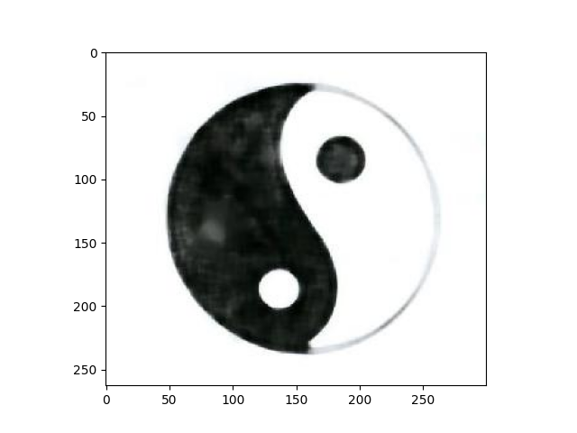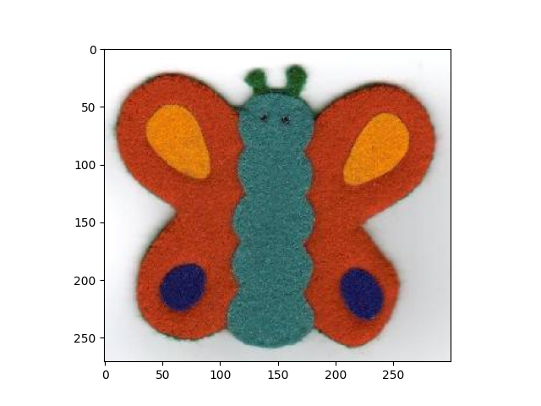

Conclusions:

In this project, we discussed about image_features and its extractions. How image features can be represented in vector spaces and how to find similar images. I got good results for color moments and ResNet layers avg_pool, fully connected and layer3. HOG results are not good due to the background texture showing in the image.

Appendix:

The team divided each feature among ourselves to find the best similarity measure for each feature descriptor.

For Colour Moments – Done by Surya Makkena. Finalized Manhattan as Similarity measure. I implemented various similarity functions and found that Manhattan distance gives best matching images. The Manhattan distance or Minkowski 1 degree similarity measure calculates the dissimilar between the colours and the less dissimilarity is given as similar images. The minkowski with 0.25 degree gives better results but since its not a similarity measure, I ignored it.

For HOG – Done by Devanshu Gupta. He implemented various similarity methods and found that pearsons corelation gives better images.

Avg_Pool – Done by Surya. Used Euclidian distance which gave better results compared to other similarity measures

Layer 3 – Done by Vishal Reddy Eda. Finalized Euclidian distance

Fully Connected – Done by Sonal, Finalized cosine distance measure